DESCRIPTIVE STATISTICS

NEW FILE.

DATASET NAME DataSet1 WINDOW=FRONT.

GET DATA

/TYPE=XLSX

/FILE='E:\APP_WORKS\Data consolidated.xlsx'

/SHEET=name 'Financial Stress_June 17, 2021_'

/CELLRANGE=FULL

/READNAMES=ON

/DATATYPEMIN PERCENTAGE=95.0

/HIDDEN IGNORE=YES.

EXECUTE.

DATASET NAME DataSet2 WINDOW=FRONT.

DESCRIPTIVES VARIABLES=V1 V2 V3 V5 V6 V7 V8 DemographicbackgroundVariables V20 V21 V22 V23 V24 V25

V26 V27 V28 V29 V30 V32 V33 V35 FinancialUncertaintyaspredictorvariable V38 V39 V40 V41

FinancialUncertaintySupplementaryanalysisPeoplesbehaviorchangeon V43 V44 V45 V46 V47 V48 V49 V50

V51 V52 V53 V54 V55 V56 FinancialworriesModerating V58 V59 V60

WorkValueasmoderator：TowhatextentisitIMPORTANTforyoutohaveajob V62 V63 V64 V65 V66 V67 V68

WorkValueasmoderator：TowhatextentisitIMPORTANTforyoutoworkfora V70 V71 V72 V73 V74 V75 V76

Presenteeism_dayscategoricalvariable

PresenteeismDaysSupplementaryanalysis1Counterproductiveworkbehav V79 V80 V81 V82 V83 V84 V85 V86

V87 PresenteeismDaysSupplementaryanalysis2TheCognitiveFailuresQuesti V89 V90 V91 V92 V93 V94 V95

V96 V97 V98 V99 V100 V101 V102 V103 V104 V105 V106 V107 V108 V109 V110 V111 V112

HowrespondentsseethemselvesSuchasextravertedenthusiasticcritical V114 V115 V116 V117 V118 V119 V120

V121 V122 MarkerItems V124 V125 V126

/STATISTICS=MEAN STDDEV MIN MAX.

**Descriptives**

[DataSet2]

|  |  |  |  |  |  |
| --- | --- | --- | --- | --- | --- |
| **Descriptive Statistics** | | | | | |
|  | N | Minimum | Maximum | Mean | Std. Deviation |
| V1 | 234 | 06-AUG-20 | 16-SEP-20 | 08-AUG-20 | 2 13:15:48.663 |
| V2 | 234 | 06-AUG-20 | 16-SEP-20 | 08-AUG-20 | 2 13:17:12.586 |
| V3 | 234 | 0 | 0 | .00 | .000 |
| V5 | 234 | 4 | 100 | 90.69 | 24.985 |
| V6 | 234 | 5 | 235918 | 2191.42 | 16363.502 |
| V7 | 234 | 0 | 1 | .85 | .353 |
| V8 | 234 | 08-AUG-2020 | 23-SEP-2020 | 09-AUG-2020 | 3 19:45:37.449 |
| Demographic/background Variables | 227 | 1 | 3 | 1.43 | .505 |
| V20 | 227 | 1 | 188 | 183.17 | 25.696 |
| V21 | 227 | 1 | 7 | 4.48 | 1.270 |
| V22 | 227 | 1 | 6 | 3.33 | 1.514 |
| V23 | 209 | 1 | 2 | 1.12 | .331 |
| V24 | 209 | 0 | 11 | 4.44 | 3.136 |
| V25 | 209 | 0 | 11 | 4.51 | 3.106 |
| V26 | 209 | 0 | 11 | 3.97 | 3.653 |
| V27 | 209 | 0 | 26 | 5.59 | 5.152 |
| V28 | 209 | 0 | 30 | 6.70 | 6.171 |
| V29 | 209 | 0 | 30 | 14.77 | 9.790 |
| V30 | 209 | 1 | 4 | 1.27 | .710 |
| V32 | 209 | 1 | 7 | 2.42 | 1.639 |
| V33 | 209 | 1 | 11 | 5.61 | 3.027 |
| V35 | 209 | 1 | 7 | 1.88 | 1.606 |
| Financial Uncertainty  as predictor variable | 208 | 1 | 7 | 4.81 | 1.579 |
| V38 | 208 | 1 | 7 | 5.11 | 1.676 |
| V39 | 208 | 1 | 7 | 4.87 | 1.734 |
| V40 | 208 | 1 | 7 | 4.63 | 1.855 |
| V41 | 207 | 1 | 7 | 4.35 | 1.840 |
| Financial Uncertainty Supplementary analysis:  People's behavior change on Self-development | 208 | 0 | 6 | 2.97 | 1.697 |
| V43 | 208 | 0 | 6 | 2.89 | 1.517 |
| V44 | 208 | 0 | 6 | 3.07 | 1.576 |
| V45 | 208 | 0 | 6 | 1.82 | 1.856 |
| V46 | 208 | 0 | 6 | 1.99 | 1.843 |
| V47 | 208 | 0 | 6 | 3.63 | 1.539 |
| V48 | 208 | 0 | 6 | 3.51 | 1.642 |
| V49 | 208 | 0 | 6 | 1.84 | 1.802 |
| V50 | 208 | 0 | 6 | 2.06 | 1.838 |
| V51 | 208 | 0 | 6 | 2.88 | 1.610 |
| V52 | 208 | 0 | 6 | 3.28 | 1.650 |
| V53 | 208 | 0 | 6 | 3.57 | 1.593 |
| V54 | 208 | 0 | 6 | 1.91 | 1.826 |
| V55 | 208 | 0 | 6 | 2.76 | 1.642 |
| V56 | 208 | 0 | 6 | 2.66 | 1.756 |
| Financial worries  Moderating | 208 | 0 | 6 | 2.75 | 1.817 |
| V58 | 208 | 0 | 6 | 2.77 | 1.718 |
| V59 | 208 | 0 | 6 | 2.34 | 1.881 |
| V60 | 208 | 0 | 6 | 2.68 | 1.984 |
| Work Value as moderator： To what extent is it IMPORTANT for you to have a job that… | 208 | 1 | 5 | 2.39 | 1.265 |
| V62 | 208 | 1 | 5 | 2.48 | 1.326 |
| V63 | 208 | 1 | 5 | 2.36 | 1.292 |
| V64 | 208 | 1 | 5 | 3.49 | 1.063 |
| V65 | 208 | 1 | 5 | 3.68 | 1.162 |
| V66 | 208 | 1 | 5 | 3.79 | 1.063 |
| V67 | 208 | 1 | 5 | 3.49 | 1.138 |
| V68 | 208 | 1 | 5 | 3.35 | 1.245 |
| Work Value as moderator： To what extent is it IMPORTANT for you to work for an organization that… | 207 | 1 | 5 | 2.56 | 1.245 |
| V70 | 207 | 1 | 5 | 2.83 | 1.287 |
| V71 | 207 | 1 | 5 | 2.51 | 1.329 |
| V72 | 207 | 1 | 5 | 3.23 | 1.266 |
| V73 | 207 | 1 | 5 | 3.59 | 1.093 |
| V74 | 207 | 1 | 5 | 3.50 | 1.161 |
| V75 | 207 | 1 | 5 | 3.57 | 1.116 |
| V76 | 207 | 1 | 5 | 3.42 | 1.263 |
| Presenteeism_days  (categorical variable) | 206 | 0 | 2 | .30 | .547 |
| Presenteeism Days Supplementary analysis 1:  Counterproductive work behaviors (CPBs) (People's behavior change at workplace) | 206 | 0 | 6 | 1.02 | 1.543 |
| V79 | 206 | 0 | 6 | .76 | 1.516 |
| V80 | 206 | 0 | 6 | 1.24 | 1.608 |
| V81 | 206 | 0 | 6 | 1.15 | 1.515 |
| V82 | 206 | 0 | 6 | 1.01 | 1.562 |
| V83 | 206 | 0 | 6 | 1.20 | 1.529 |
| V84 | 206 | 0 | 6 | .96 | 1.538 |
| V85 | 206 | 0 | 6 | .85 | 1.671 |
| V86 | 206 | 0 | 6 | .77 | 1.565 |
| V87 | 206 | 0 | 6 | 1.07 | 1.648 |
| Presenteeism Days Supplementary analysis 2:  The Cognitive Failures Questionnaire (People's behavior in daily life) | 206 | 1 | 5 | 3.42 | 1.008 |
| V89 | 206 | 1 | 5 | 3.69 | 1.090 |
| V90 | 206 | 1 | 5 | 3.96 | 1.149 |
| V91 | 206 | 1 | 5 | 4.14 | 1.183 |
| V92 | 206 | 1 | 5 | 4.15 | 1.127 |
| V93 | 206 | 1 | 5 | 3.83 | 1.060 |
| V94 | 206 | 1 | 5 | 3.50 | 1.147 |
| V95 | 206 | 1 | 5 | 3.72 | 1.112 |
| V96 | 206 | 1 | 5 | 3.72 | 1.138 |
| V97 | 206 | 1 | 5 | 3.89 | 1.095 |
| V98 | 206 | 1 | 5 | 3.77 | 1.251 |
| V99 | 206 | 1 | 5 | 4.10 | 1.177 |
| V100 | 206 | 1 | 5 | 3.88 | 1.177 |
| V101 | 206 | 1 | 5 | 3.90 | 1.122 |
| V102 | 206 | 1 | 5 | 3.46 | 1.171 |
| V103 | 206 | 1 | 5 | 4.14 | 1.165 |
| V104 | 206 | 1 | 5 | 3.78 | 1.137 |
| V105 | 206 | 1 | 5 | 4.13 | 1.159 |
| V106 | 206 | 1 | 5 | 3.64 | 1.159 |
| V107 | 206 | 1 | 5 | 3.57 | 1.144 |
| V108 | 206 | 1 | 5 | 3.54 | 1.137 |
| V109 | 206 | 1 | 5 | 3.41 | 1.035 |
| V110 | 206 | 1 | 5 | 3.87 | 1.172 |
| V111 | 206 | 1 | 5 | 3.90 | 1.102 |
| V112 | 206 | 1 | 5 | 3.76 | 1.135 |
| How respondents see themselves? Such as extraverted enthusiastic, critical, self-disciplined, etc. | 205 | 1 | 7 | 4.22 | 1.994 |
| V114 | 205 | 1 | 7 | 2.72 | 1.804 |
| V115 | 205 | 1 | 7 | 5.71 | 1.230 |
| V116 | 205 | 1 | 7 | 3.24 | 1.973 |
| V117 | 205 | 1 | 7 | 5.19 | 1.475 |
| V118 | 205 | 1 | 7 | 4.66 | 1.928 |
| V119 | 205 | 1 | 7 | 5.60 | 1.327 |
| V120 | 205 | 1 | 7 | 2.62 | 1.761 |
| V121 | 205 | 1 | 7 | 5.41 | 1.455 |
| V122 | 205 | 1 | 7 | 2.92 | 1.737 |
| Marker Items | 203 | 1 | 5 | 1.94 | 1.120 |
| V124 | 203 | 1 | 5 | 1.37 | .894 |
| V125 | 203 | 1 | 5 | 2.11 | 1.118 |
| V126 | 203 | 1 | 5 | 1.91 | 1.079 |
| Valid N (listwise) | 202 |  |  |  |  |

**Frequencies Analysis of the Party Variables**

|  |  |  |  |  |  |
| --- | --- | --- | --- | --- | --- |
| **V1** | | | | | |
|  | | Frequency | Percent | Valid Percent | Cumulative Percent |
| Valid | 06-AUG-20 | 1 | .4 | .4 | .4 |
| 07-AUG-20 | 1 | .4 | .4 | .9 |
| 08-AUG-20 | 1 | .4 | .4 | 1.3 |
| 08-AUG-20 | 1 | .4 | .4 | 1.7 |
| 08-AUG-20 | 1 | .4 | .4 | 2.1 |
| 08-AUG-20 | 1 | .4 | .4 | 2.6 |
| 08-AUG-20 | 1 | .4 | .4 | 3.0 |
| 08-AUG-20 | 1 | .4 | .4 | 3.4 |
| 08-AUG-20 | 1 | .4 | .4 | 3.8 |
| 08-AUG-20 | 1 | .4 | .4 | 4.3 |
| 08-AUG-20 | 1 | .4 | .4 | 4.7 |
| 08-AUG-20 | 1 | .4 | .4 | 5.1 |
| 08-AUG-20 | 2 | .8 | .9 | 6.0 |
| 08-AUG-20 | 2 | .8 | .9 | 6.8 |
| 08-AUG-20 | 1 | .4 | .4 | 7.3 |
| 08-AUG-20 | 1 | .4 | .4 | 7.7 |
| 08-AUG-20 | 1 | .4 | .4 | 8.1 |
| 08-AUG-20 | 1 | .4 | .4 | 8.5 |
| 08-AUG-20 | 1 | .4 | .4 | 9.0 |
| 08-AUG-20 | 1 | .4 | .4 | 9.4 |
| 08-AUG-20 | 1 | .4 | .4 | 9.8 |
| 08-AUG-20 | 1 | .4 | .4 | 10.3 |
| 08-AUG-20 | 1 | .4 | .4 | 10.7 |
| 08-AUG-20 | 1 | .4 | .4 | 11.1 |
| 08-AUG-20 | 1 | .4 | .4 | 11.5 |
| 08-AUG-20 | 1 | .4 | .4 | 12.0 |
| 08-AUG-20 | 1 | .4 | .4 | 12.4 |
| 08-AUG-20 | 1 | .4 | .4 | 12.8 |
| 08-AUG-20 | 2 | .8 | .9 | 13.7 |
| 08-AUG-20 | 1 | .4 | .4 | 14.1 |
| 08-AUG-20 | 1 | .4 | .4 | 14.5 |
| 08-AUG-20 | 1 | .4 | .4 | 15.0 |
| 08-AUG-20 | 1 | .4 | .4 | 15.4 |
| 08-AUG-20 | 1 | .4 | .4 | 15.8 |
| 08-AUG-20 | 2 | .8 | .9 | 16.7 |
| 08-AUG-20 | 1 | .4 | .4 | 17.1 |
| 08-AUG-20 | 1 | .4 | .4 | 17.5 |
| 08-AUG-20 | 1 | .4 | .4 | 17.9 |
| 08-AUG-20 | 1 | .4 | .4 | 18.4 |
| 08-AUG-20 | 1 | .4 | .4 | 18.8 |
| 08-AUG-20 | 1 | .4 | .4 | 19.2 |
| 08-AUG-20 | 1 | .4 | .4 | 19.7 |
| 08-AUG-20 | 1 | .4 | .4 | 20.1 |
| 08-AUG-20 | 1 | .4 | .4 | 20.5 |
| 08-AUG-20 | 1 | .4 | .4 | 20.9 |
| 08-AUG-20 | 1 | .4 | .4 | 21.4 |
| 08-AUG-20 | 1 | .4 | .4 | 21.8 |
| 08-AUG-20 | 1 | .4 | .4 | 22.2 |
| 08-AUG-20 | 1 | .4 | .4 | 22.6 |
| 08-AUG-20 | 1 | .4 | .4 | 23.1 |
| 08-AUG-20 | 1 | .4 | .4 | 23.5 |
| 08-AUG-20 | 1 | .4 | .4 | 23.9 |
| 08-AUG-20 | 1 | .4 | .4 | 24.4 |
| 08-AUG-20 | 1 | .4 | .4 | 24.8 |
| 08-AUG-20 | 1 | .4 | .4 | 25.2 |
| 08-AUG-20 | 1 | .4 | .4 | 25.6 |
| 08-AUG-20 | 1 | .4 | .4 | 26.1 |
| 08-AUG-20 | 1 | .4 | .4 | 26.5 |
| 08-AUG-20 | 1 | .4 | .4 | 26.9 |
| 08-AUG-20 | 1 | .4 | .4 | 27.4 |
| 08-AUG-20 | 1 | .4 | .4 | 27.8 |
| 08-AUG-20 | 1 | .4 | .4 | 28.2 |
| 08-AUG-20 | 3 | 1.3 | 1.3 | 29.5 |
| 08-AUG-20 | 1 | .4 | .4 | 29.9 |
| 08-AUG-20 | 1 | .4 | .4 | 30.3 |
| 08-AUG-20 | 1 | .4 | .4 | 30.8 |
| 08-AUG-20 | 1 | .4 | .4 | 31.2 |
| 08-AUG-20 | 1 | .4 | .4 | 31.6 |
| 08-AUG-20 | 1 | .4 | .4 | 32.1 |
| 08-AUG-20 | 1 | .4 | .4 | 32.5 |
| 08-AUG-20 | 1 | .4 | .4 | 32.9 |
| 08-AUG-20 | 1 | .4 | .4 | 33.3 |
| 08-AUG-20 | 1 | .4 | .4 | 33.8 |
| 08-AUG-20 | 1 | .4 | .4 | 34.2 |
| 08-AUG-20 | 1 | .4 | .4 | 34.6 |
| 08-AUG-20 | 1 | .4 | .4 | 35.0 |
| 08-AUG-20 | 1 | .4 | .4 | 35.5 |
| 08-AUG-20 | 1 | .4 | .4 | 35.9 |
| 08-AUG-20 | 1 | .4 | .4 | 36.3 |
| 08-AUG-20 | 1 | .4 | .4 | 36.8 |
| 08-AUG-20 | 1 | .4 | .4 | 37.2 |
| 08-AUG-20 | 1 | .4 | .4 | 37.6 |
| 08-AUG-20 | 1 | .4 | .4 | 38.0 |
| 08-AUG-20 | 1 | .4 | .4 | 38.5 |
| 08-AUG-20 | 1 | .4 | .4 | 38.9 |
| 08-AUG-20 | 1 | .4 | .4 | 39.3 |
| 08-AUG-20 | 1 | .4 | .4 | 39.7 |
| 08-AUG-20 | 1 | .4 | .4 | 40.2 |
| 08-AUG-20 | 1 | .4 | .4 | 40.6 |
| 08-AUG-20 | 1 | .4 | .4 | 41.0 |
| 08-AUG-20 | 1 | .4 | .4 | 41.5 |
| 08-AUG-20 | 1 | .4 | .4 | 41.9 |
| 08-AUG-20 | 1 | .4 | .4 | 42.3 |
| 08-AUG-20 | 1 | .4 | .4 | 42.7 |
| 08-AUG-20 | 1 | .4 | .4 | 43.2 |
| 08-AUG-20 | 1 | .4 | .4 | 43.6 |
| 08-AUG-20 | 1 | .4 | .4 | 44.0 |
| 08-AUG-20 | 1 | .4 | .4 | 44.4 |
| 08-AUG-20 | 1 | .4 | .4 | 44.9 |
| 08-AUG-20 | 1 | .4 | .4 | 45.3 |
| 08-AUG-20 | 1 | .4 | .4 | 45.7 |
| 08-AUG-20 | 1 | .4 | .4 | 46.2 |
| 08-AUG-20 | 1 | .4 | .4 | 46.6 |
| 08-AUG-20 | 1 | .4 | .4 | 47.0 |
| 08-AUG-20 | 1 | .4 | .4 | 47.4 |
| 08-AUG-20 | 1 | .4 | .4 | 47.9 |
| 08-AUG-20 | 1 | .4 | .4 | 48.3 |
| 08-AUG-20 | 1 | .4 | .4 | 48.7 |
| 08-AUG-20 | 1 | .4 | .4 | 49.1 |
| 08-AUG-20 | 1 | .4 | .4 | 49.6 |
| 08-AUG-20 | 1 | .4 | .4 | 50.0 |
| 08-AUG-20 | 1 | .4 | .4 | 50.4 |
| 08-AUG-20 | 1 | .4 | .4 | 50.9 |
| 08-AUG-20 | 1 | .4 | .4 | 51.3 |
| 08-AUG-20 | 1 | .4 | .4 | 51.7 |
| 08-AUG-20 | 1 | .4 | .4 | 52.1 |
| 08-AUG-20 | 1 | .4 | .4 | 52.6 |
| 08-AUG-20 | 1 | .4 | .4 | 53.0 |
| 08-AUG-20 | 1 | .4 | .4 | 53.4 |
| 08-AUG-20 | 1 | .4 | .4 | 53.8 |
| 08-AUG-20 | 1 | .4 | .4 | 54.3 |
| 08-AUG-20 | 1 | .4 | .4 | 54.7 |
| 08-AUG-20 | 1 | .4 | .4 | 55.1 |
| 08-AUG-20 | 1 | .4 | .4 | 55.6 |
| 08-AUG-20 | 1 | .4 | .4 | 56.0 |
| 08-AUG-20 | 1 | .4 | .4 | 56.4 |
| 08-AUG-20 | 1 | .4 | .4 | 56.8 |
| 08-AUG-20 | 1 | .4 | .4 | 57.3 |
| 08-AUG-20 | 1 | .4 | .4 | 57.7 |
| 08-AUG-20 | 1 | .4 | .4 | 58.1 |
| 08-AUG-20 | 1 | .4 | .4 | 58.5 |
| 08-AUG-20 | 1 | .4 | .4 | 59.0 |
| 08-AUG-20 | 1 | .4 | .4 | 59.4 |
| 08-AUG-20 | 1 | .4 | .4 | 59.8 |
| 08-AUG-20 | 1 | .4 | .4 | 60.3 |
| 08-AUG-20 | 1 | .4 | .4 | 60.7 |
| 08-AUG-20 | 1 | .4 | .4 | 61.1 |
| 08-AUG-20 | 1 | .4 | .4 | 61.5 |
| 08-AUG-20 | 1 | .4 | .4 | 62.0 |
| 08-AUG-20 | 1 | .4 | .4 | 62.4 |
| 08-AUG-20 | 1 | .4 | .4 | 62.8 |
| 08-AUG-20 | 1 | .4 | .4 | 63.2 |
| 08-AUG-20 | 1 | .4 | .4 | 63.7 |
| 08-AUG-20 | 1 | .4 | .4 | 64.1 |
| 08-AUG-20 | 2 | .8 | .9 | 65.0 |
| 08-AUG-20 | 1 | .4 | .4 | 65.4 |
| 08-AUG-20 | 1 | .4 | .4 | 65.8 |
| 08-AUG-20 | 2 | .8 | .9 | 66.7 |
| 08-AUG-20 | 1 | .4 | .4 | 67.1 |
| 08-AUG-20 | 1 | .4 | .4 | 67.5 |
| 08-AUG-20 | 1 | .4 | .4 | 67.9 |
| 08-AUG-20 | 1 | .4 | .4 | 68.4 |
| 08-AUG-20 | 1 | .4 | .4 | 68.8 |
| 08-AUG-20 | 1 | .4 | .4 | 69.2 |
| 08-AUG-20 | 1 | .4 | .4 | 69.7 |
| 08-AUG-20 | 1 | .4 | .4 | 70.1 |
| 08-AUG-20 | 1 | .4 | .4 | 70.5 |
| 08-AUG-20 | 1 | .4 | .4 | 70.9 |
| 08-AUG-20 | 1 | .4 | .4 | 71.4 |
| 08-AUG-20 | 1 | .4 | .4 | 71.8 |
| 08-AUG-20 | 1 | .4 | .4 | 72.2 |
| 08-AUG-20 | 1 | .4 | .4 | 72.6 |
| 08-AUG-20 | 1 | .4 | .4 | 73.1 |
| 08-AUG-20 | 1 | .4 | .4 | 73.5 |
| 08-AUG-20 | 1 | .4 | .4 | 73.9 |
| 08-AUG-20 | 1 | .4 | .4 | 74.4 |
| 08-AUG-20 | 1 | .4 | .4 | 74.8 |
| 08-AUG-20 | 1 | .4 | .4 | 75.2 |
| 08-AUG-20 | 1 | .4 | .4 | 75.6 |
| 08-AUG-20 | 1 | .4 | .4 | 76.1 |
| 08-AUG-20 | 1 | .4 | .4 | 76.5 |
| 08-AUG-20 | 1 | .4 | .4 | 76.9 |
| 08-AUG-20 | 1 | .4 | .4 | 77.4 |
| 08-AUG-20 | 1 | .4 | .4 | 77.8 |
| 08-AUG-20 | 1 | .4 | .4 | 78.2 |
| 08-AUG-20 | 1 | .4 | .4 | 78.6 |
| 08-AUG-20 | 1 | .4 | .4 | 79.1 |
| 08-AUG-20 | 1 | .4 | .4 | 79.5 |
| 08-AUG-20 | 1 | .4 | .4 | 79.9 |
| 08-AUG-20 | 1 | .4 | .4 | 80.3 |
| 08-AUG-20 | 1 | .4 | .4 | 80.8 |
| 08-AUG-20 | 1 | .4 | .4 | 81.2 |
| 08-AUG-20 | 1 | .4 | .4 | 81.6 |
| 08-AUG-20 | 1 | .4 | .4 | 82.1 |
| 08-AUG-20 | 1 | .4 | .4 | 82.5 |
| 08-AUG-20 | 1 | .4 | .4 | 82.9 |
| 08-AUG-20 | 1 | .4 | .4 | 83.3 |
| 08-AUG-20 | 1 | .4 | .4 | 83.8 |
| 08-AUG-20 | 1 | .4 | .4 | 84.2 |
| 08-AUG-20 | 1 | .4 | .4 | 84.6 |
| 08-AUG-20 | 1 | .4 | .4 | 85.0 |
| 08-AUG-20 | 1 | .4 | .4 | 85.5 |
| 08-AUG-20 | 1 | .4 | .4 | 85.9 |
| 08-AUG-20 | 1 | .4 | .4 | 86.3 |
| 08-AUG-20 | 1 | .4 | .4 | 86.8 |
| 08-AUG-20 | 1 | .4 | .4 | 87.2 |
| 08-AUG-20 | 1 | .4 | .4 | 87.6 |
| 08-AUG-20 | 1 | .4 | .4 | 88.0 |
| 08-AUG-20 | 1 | .4 | .4 | 88.5 |
| 08-AUG-20 | 1 | .4 | .4 | 88.9 |
| 08-AUG-20 | 1 | .4 | .4 | 89.3 |
| 08-AUG-20 | 1 | .4 | .4 | 89.7 |
| 08-AUG-20 | 1 | .4 | .4 | 90.2 |
| 08-AUG-20 | 1 | .4 | .4 | 90.6 |
| 08-AUG-20 | 1 | .4 | .4 | 91.0 |
| 08-AUG-20 | 1 | .4 | .4 | 91.5 |
| 08-AUG-20 | 1 | .4 | .4 | 91.9 |
| 08-AUG-20 | 1 | .4 | .4 | 92.3 |
| 08-AUG-20 | 1 | .4 | .4 | 92.7 |
| 08-AUG-20 | 1 | .4 | .4 | 93.2 |
| 08-AUG-20 | 1 | .4 | .4 | 93.6 |
| 08-AUG-20 | 1 | .4 | .4 | 94.0 |
| 08-AUG-20 | 1 | .4 | .4 | 94.4 |
| 08-AUG-20 | 1 | .4 | .4 | 94.9 |
| 08-AUG-20 | 1 | .4 | .4 | 95.3 |
| 08-AUG-20 | 1 | .4 | .4 | 95.7 |
| 08-AUG-20 | 1 | .4 | .4 | 96.2 |
| 08-AUG-20 | 1 | .4 | .4 | 96.6 |
| 08-AUG-20 | 1 | .4 | .4 | 97.0 |
| 08-AUG-20 | 1 | .4 | .4 | 97.4 |
| 08-AUG-20 | 1 | .4 | .4 | 97.9 |
| 08-AUG-20 | 1 | .4 | .4 | 98.3 |
| 08-AUG-20 | 1 | .4 | .4 | 98.7 |
| 08-AUG-20 | 1 | .4 | .4 | 99.1 |
| 10-AUG-20 | 1 | .4 | .4 | 99.6 |
| 16-SEP-20 | 1 | .4 | .4 | 100.0 |
| Total | 234 | 98.7 | 100.0 |  |
| Missing | System | 3 | 1.3 |  |  |
| Total | | 237 | 100.0 |  |  |

**PPlot**

|  |  |  |
| --- | --- | --- |
| **Model Description** | | |
| Model Name | | MOD_1 |
| Series or Sequence | 1 | V98 |
| 2 | V99 |
| 3 | V100 |
| 4 | V101 |
| 5 | V102 |
| 6 | V103 |
| 7 | V104 |
| 8 | V105 |
| 9 | V106 |
| 10 | V107 |
| 11 | V108 |
| 12 | V109 |
| 13 | V110 |
| 14 | V111 |
| 15 | V112 |
| 16 | How respondents see themselves? Such as extraverted enthusiastic, critical, self-disciplined, etc. |
| 17 | V114 |
| 18 | V115 |
| 19 | V116 |
| 20 | V117 |
| 21 | V118 |
| 22 | V119 |
| 23 | V120 |
| 24 | V121 |
| 25 | V122 |
| 26 | Marker Items |
| 27 | V124 |
| 28 | V125 |
| 29 | V126 |
| Transformation | | Natural logarithm |
| Non-Seasonal Differencing | | 0 |
| Seasonal Differencing | | 0 |
| Length of Seasonal Period | | No periodicity |
| Standardization | | Applied |
| Distribution | Type | Normal |
| Location | estimated |
| Scale | estimated |
| Fractional Rank Estimation Method | | Blom's |
| Rank Assigned to Ties | | Mean rank of tied values |
| Applying the model specifications from MOD_1 | | |

**V98**

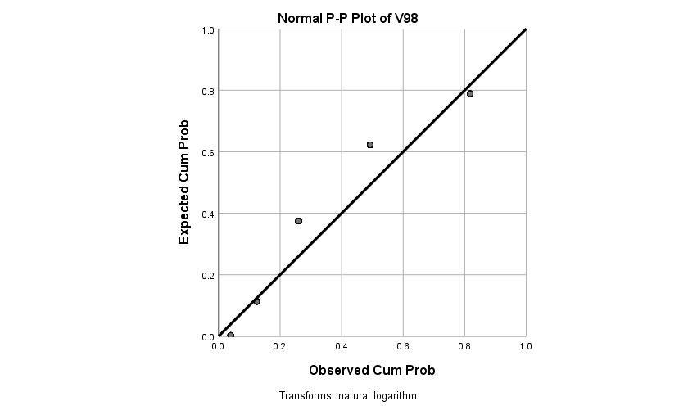

**V99**

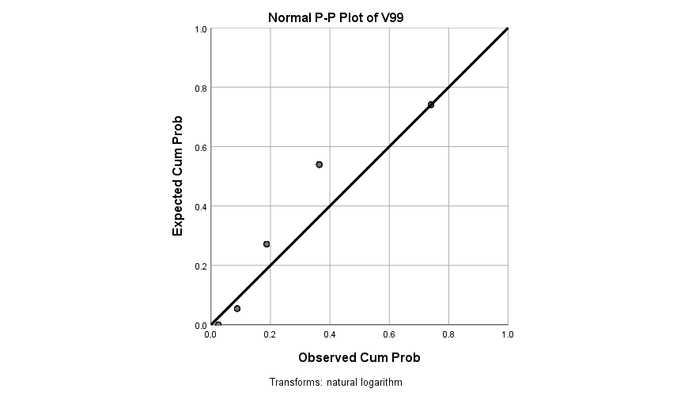

**V100**

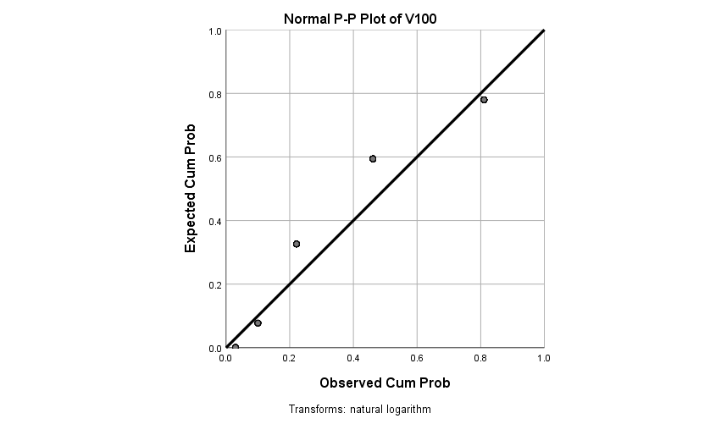

**V101**

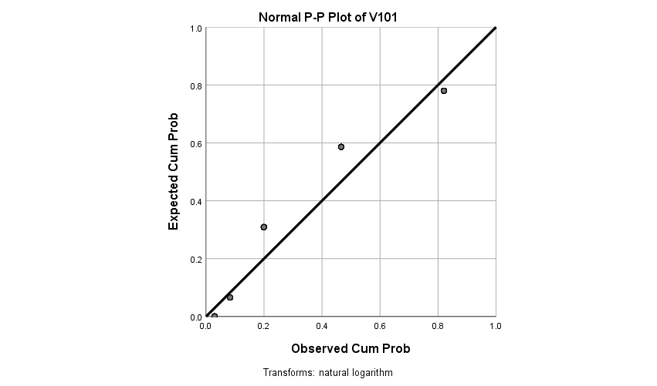

**V102**

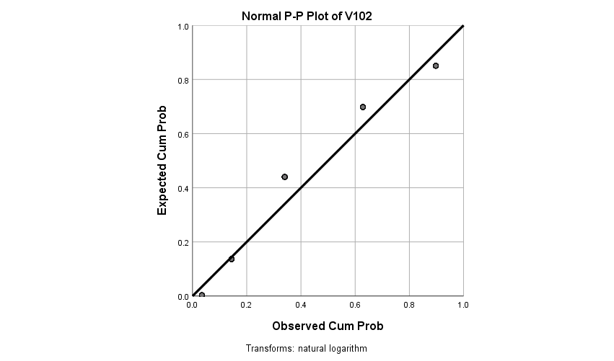

**V103**

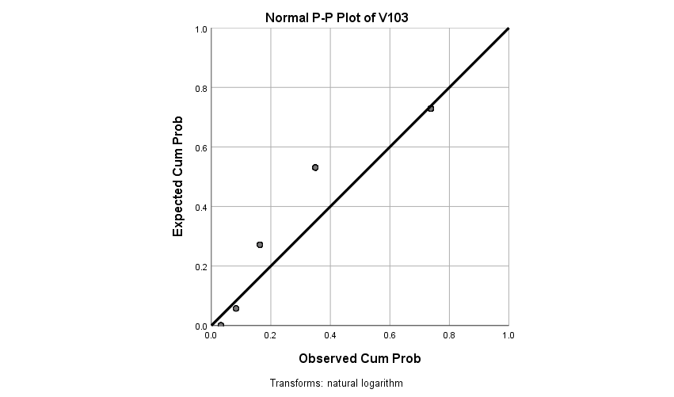

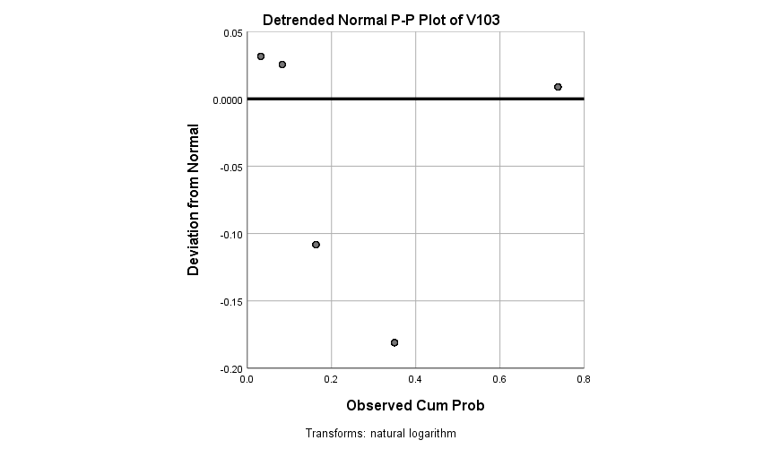

**V104**

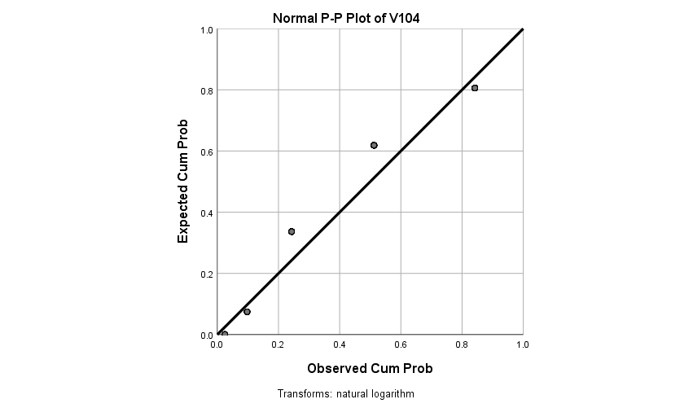

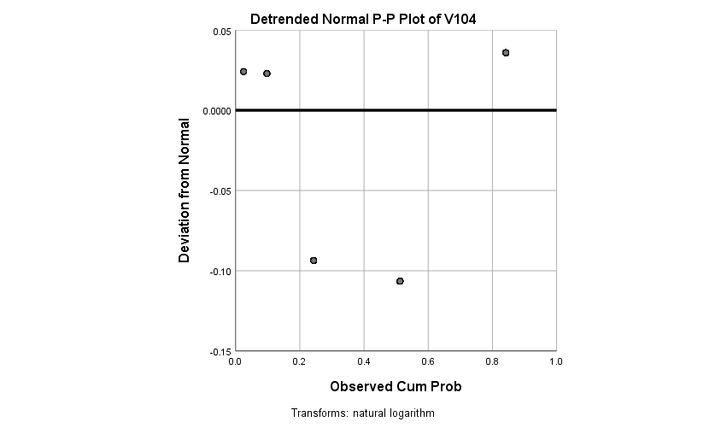

**V105**

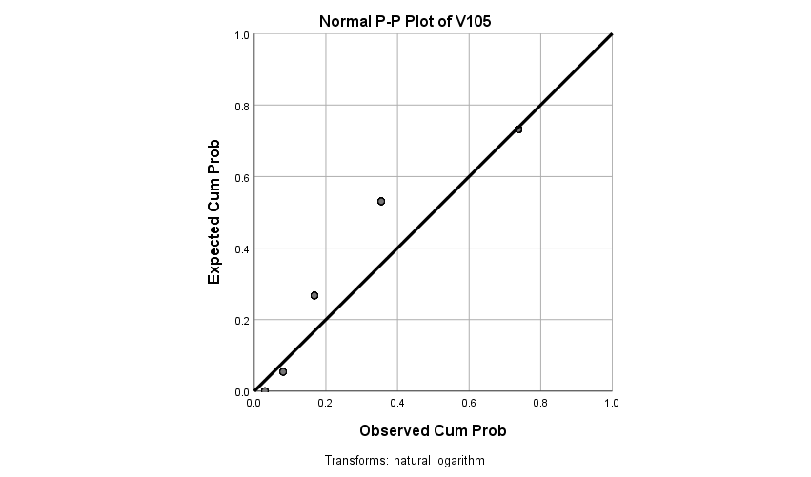

|  |  |  |  |  |  |
| --- | --- | --- | --- | --- | --- |
| **Financial worries**  **Moderating** | | | | | |
|  | | Frequency | Percent | Valid Percent | Cumulative Percent |
| Valid | 0 | 22 | 9.3 | 10.6 | 10.6 |
| 1 | 31 | 13.1 | 14.9 | 25.5 |
| 2 | 60 | 25.3 | 28.8 | 54.3 |
| 3 | 27 | 11.4 | 13.0 | 67.3 |
| 4 | 24 | 10.1 | 11.5 | 78.8 |
| 5 | 21 | 8.9 | 10.1 | 88.9 |
| 6 | 23 | 9.7 | 11.1 | 100.0 |
| Total | 208 | 87.8 | 100.0 |  |
| Missing | System | 29 | 12.2 |  |  |
| Total | | 237 | 100.0 |  |  |

|  |  |  |  |  |  |
| --- | --- | --- | --- | --- | --- |
| **V58** | | | | | |
|  | | Frequency | Percent | Valid Percent | Cumulative Percent |
| Valid | 0 | 20 | 8.4 | 9.6 | 9.6 |
| 1 | 30 | 12.7 | 14.4 | 24.0 |
| 2 | 55 | 23.2 | 26.4 | 50.5 |
| 3 | 32 | 13.5 | 15.4 | 65.9 |
| 4 | 29 | 12.2 | 13.9 | 79.8 |
| 5 | 28 | 11.8 | 13.5 | 93.3 |
| 6 | 14 | 5.9 | 6.7 | 100.0 |
| Total | 208 | 87.8 | 100.0 |  |
| Missing | System | 29 | 12.2 |  |  |
| Total | | 237 | 100.0 |  |  |

|  |  |  |  |  |  |
| --- | --- | --- | --- | --- | --- |
| **V59** | | | | | |
|  | | Frequency | Percent | Valid Percent | Cumulative Percent |
| Valid | 0 | 37 | 15.6 | 17.8 | 17.8 |
| 1 | 47 | 19.8 | 22.6 | 40.4 |
| 2 | 46 | 19.4 | 22.1 | 62.5 |
| 3 | 18 | 7.6 | 8.7 | 71.2 |
| 4 | 23 | 9.7 | 11.1 | 82.2 |
| 5 | 20 | 8.4 | 9.6 | 91.8 |
| 6 | 17 | 7.2 | 8.2 | 100.0 |
| Total | 208 | 87.8 | 100.0 |  |
| Missing | System | 29 | 12.2 |  |  |
| Total | | 237 | 100.0 |  |  |

|  |  |  |  |  |  |
| --- | --- | --- | --- | --- | --- |
| **V60** | | | | | |
|  | | Frequency | Percent | Valid Percent | Cumulative Percent |
| Valid | 0 | 28 | 11.8 | 13.5 | 13.5 |
| 1 | 45 | 19.0 | 21.6 | 35.1 |
| 2 | 43 | 18.1 | 20.7 | 55.8 |
| 3 | 18 | 7.6 | 8.7 | 64.4 |
| 4 | 25 | 10.5 | 12.0 | 76.4 |
| 5 | 21 | 8.9 | 10.1 | 86.5 |
| 6 | 28 | 11.8 | 13.5 | 100.0 |
| Total | 208 | 87.8 | 100.0 |  |
| Missing | System | 29 | 12.2 |  |  |
| Total | | 237 | 100.0 |  |  |

|  |  |  |  |  |  |
| --- | --- | --- | --- | --- | --- |
| **Work Value as moderator： To what extent is it IMPORTANT for you to have a job that…** | | | | | |
|  | | Frequency | Percent | Valid Percent | Cumulative Percent |
| Valid | 1 | 68 | 28.7 | 32.7 | 32.7 |
| 2 | 54 | 22.8 | 26.0 | 58.7 |
| 3 | 33 | 13.9 | 15.9 | 74.5 |
| 4 | 43 | 18.1 | 20.7 | 95.2 |
| 5 | 10 | 4.2 | 4.8 | 100.0 |
| Total | 208 | 87.8 | 100.0 |  |
| Missing | System | 29 | 12.2 |  |  |
| Total | | 237 | 100.0 |  |  |

|  |  |  |  |  |  |
| --- | --- | --- | --- | --- | --- |
| **V62** | | | | | |
|  | | Frequency | Percent | Valid Percent | Cumulative Percent |
| Valid | 1 | 66 | 27.8 | 31.7 | 31.7 |
| 2 | 48 | 20.3 | 23.1 | 54.8 |
| 3 | 40 | 16.9 | 19.2 | 74.0 |
| 4 | 36 | 15.2 | 17.3 | 91.3 |
| 5 | 18 | 7.6 | 8.7 | 100.0 |
| Total | 208 | 87.8 | 100.0 |  |
| Missing | System | 29 | 12.2 |  |  |
| Total | | 237 | 100.0 |  |  |

|  |  |  |  |  |  |
| --- | --- | --- | --- | --- | --- |
| **V63** | | | | | |
|  | | Frequency | Percent | Valid Percent | Cumulative Percent |
| Valid | 1 | 76 | 32.1 | 36.5 | 36.5 |
| 2 | 40 | 16.9 | 19.2 | 55.8 |
| 3 | 49 | 20.7 | 23.6 | 79.3 |
| 4 | 28 | 11.8 | 13.5 | 92.8 |
| 5 | 15 | 6.3 | 7.2 | 100.0 |
| Total | 208 | 87.8 | 100.0 |  |
| Missing | System | 29 | 12.2 |  |  |
| Total | | 237 | 100.0 |  |  |

|  |  |  |  |  |  |
| --- | --- | --- | --- | --- | --- |
| **V64** | | | | | |
|  | | Frequency | Percent | Valid Percent | Cumulative Percent |
| Valid | 1 | 11 | 4.6 | 5.3 | 5.3 |
| 2 | 22 | 9.3 | 10.6 | 15.9 |
| 3 | 65 | 27.4 | 31.3 | 47.1 |
| 4 | 74 | 31.2 | 35.6 | 82.7 |
| 5 | 36 | 15.2 | 17.3 | 100.0 |
| Total | 208 | 87.8 | 100.0 |  |
| Missing | System | 29 | 12.2 |  |  |
| Total | | 237 | 100.0 |  |  |

|  |  |  |  |  |  |
| --- | --- | --- | --- | --- | --- |
| **V65** | | | | | |
|  | | Frequency | Percent | Valid Percent | Cumulative Percent |
| Valid | 1 | 10 | 4.2 | 4.8 | 4.8 |
| 2 | 27 | 11.4 | 13.0 | 17.8 |
| 3 | 43 | 18.1 | 20.7 | 38.5 |
| 4 | 68 | 28.7 | 32.7 | 71.2 |
| 5 | 60 | 25.3 | 28.8 | 100.0 |
| Total | 208 | 87.8 | 100.0 |  |
| Missing | System | 29 | 12.2 |  |  |
| Total | | 237 | 100.0 |  |  |

|  |  |  |  |  |  |
| --- | --- | --- | --- | --- | --- |
| **V66** | | | | | |
|  | | Frequency | Percent | Valid Percent | Cumulative Percent |
| Valid | 1 | 5 | 2.1 | 2.4 | 2.4 |
| 2 | 21 | 8.9 | 10.1 | 12.5 |
| 3 | 50 | 21.1 | 24.0 | 36.5 |
| 4 | 68 | 28.7 | 32.7 | 69.2 |
| 5 | 64 | 27.0 | 30.8 | 100.0 |
| Total | 208 | 87.8 | 100.0 |  |
| Missing | System | 29 | 12.2 |  |  |
| Total | | 237 | 100.0 |  |  |

|  |  |  |  |  |  |
| --- | --- | --- | --- | --- | --- |
| **V67** | | | | | |
|  | | Frequency | Percent | Valid Percent | Cumulative Percent |
| Valid | 1 | 12 | 5.1 | 5.8 | 5.8 |
| 2 | 29 | 12.2 | 13.9 | 19.7 |
| 3 | 55 | 23.2 | 26.4 | 46.2 |
| 4 | 69 | 29.1 | 33.2 | 79.3 |
| 5 | 43 | 18.1 | 20.7 | 100.0 |
| Total | 208 | 87.8 | 100.0 |  |
| Missing | System | 29 | 12.2 |  |  |
| Total | | 237 | 100.0 |  |  |

|  |  |  |  |  |  |
| --- | --- | --- | --- | --- | --- |
| **V68** | | | | | |
|  | | Frequency | Percent | Valid Percent | Cumulative Percent |
| Valid | 1 | 18 | 7.6 | 8.7 | 8.7 |
| 2 | 38 | 16.0 | 18.3 | 26.9 |
| 3 | 51 | 21.5 | 24.5 | 51.4 |
| 4 | 56 | 23.6 | 26.9 | 78.4 |
| 5 | 45 | 19.0 | 21.6 | 100.0 |
| Total | 208 | 87.8 | 100.0 |  |
| Missing | System | 29 | 12.2 |  |  |
| Total | | 237 | 100.0 |  |  |

|  |  |  |  |  |  |
| --- | --- | --- | --- | --- | --- |
| **Work Value as moderator： To what extent is it IMPORTANT for you to work for an organization that…** | | | | | |
|  | | Frequency | Percent | Valid Percent | Cumulative Percent |
| Valid | 1 | 54 | 22.8 | 26.1 | 26.1 |
| 2 | 50 | 21.1 | 24.2 | 50.2 |
| 3 | 51 | 21.5 | 24.6 | 74.9 |
| 4 | 38 | 16.0 | 18.4 | 93.2 |
| 5 | 14 | 5.9 | 6.8 | 100.0 |
| Total | 207 | 87.3 | 100.0 |  |
| Missing | System | 30 | 12.7 |  |  |
| Total | | 237 | 100.0 |  |  |

|  |  |  |  |  |  |
| --- | --- | --- | --- | --- | --- |
| **V70** | | | | | |
|  | | Frequency | Percent | Valid Percent | Cumulative Percent |
| Valid | 1 | 42 | 17.7 | 20.3 | 20.3 |
| 2 | 42 | 17.7 | 20.3 | 40.6 |
| 3 | 55 | 23.2 | 26.6 | 67.1 |
| 4 | 45 | 19.0 | 21.7 | 88.9 |
| 5 | 23 | 9.7 | 11.1 | 100.0 |
| Total | 207 | 87.3 | 100.0 |  |
| Missing | System | 30 | 12.7 |  |  |
| Total | | 237 | 100.0 |  |  |

|  |  |  |  |  |  |
| --- | --- | --- | --- | --- | --- |
| **V71** | | | | | |
|  | | Frequency | Percent | Valid Percent | Cumulative Percent |
| Valid | 1 | 68 | 28.7 | 32.9 | 32.9 |
| 2 | 36 | 15.2 | 17.4 | 50.2 |
| 3 | 49 | 20.7 | 23.7 | 73.9 |
| 4 | 37 | 15.6 | 17.9 | 91.8 |
| 5 | 17 | 7.2 | 8.2 | 100.0 |
| Total | 207 | 87.3 | 100.0 |  |
| Missing | System | 30 | 12.7 |  |  |
| Total | | 237 | 100.0 |  |  |

|  |  |  |  |  |  |
| --- | --- | --- | --- | --- | --- |
| **V72** | | | | | |
|  | | Frequency | Percent | Valid Percent | Cumulative Percent |
| Valid | 1 | 24 | 10.1 | 11.6 | 11.6 |
| 2 | 38 | 16.0 | 18.4 | 30.0 |
| 3 | 49 | 20.7 | 23.7 | 53.6 |
| 4 | 59 | 24.9 | 28.5 | 82.1 |
| 5 | 37 | 15.6 | 17.9 | 100.0 |
| Total | 207 | 87.3 | 100.0 |  |
| Missing | System | 30 | 12.7 |  |  |
| Total | | 237 | 100.0 |  |  |

|  |  |  |  |  |  |
| --- | --- | --- | --- | --- | --- |
| **V73** | | | | | |
|  | | Frequency | Percent | Valid Percent | Cumulative Percent |
| Valid | 1 | 12 | 5.1 | 5.8 | 5.8 |
| 2 | 18 | 7.6 | 8.7 | 14.5 |
| 3 | 56 | 23.6 | 27.1 | 41.5 |
| 4 | 77 | 32.5 | 37.2 | 78.7 |
| 5 | 44 | 18.6 | 21.3 | 100.0 |
| Total | 207 | 87.3 | 100.0 |  |
| Missing | System | 30 | 12.7 |  |  |
| Total | | 237 | 100.0 |  |  |

|  |  |  |  |  |  |
| --- | --- | --- | --- | --- | --- |
| **V74** | | | | | |
|  | | Frequency | Percent | Valid Percent | Cumulative Percent |
| Valid | 1 | 17 | 7.2 | 8.2 | 8.2 |
| 2 | 20 | 8.4 | 9.7 | 17.9 |
| 3 | 55 | 23.2 | 26.6 | 44.4 |
| 4 | 73 | 30.8 | 35.3 | 79.7 |
| 5 | 42 | 17.7 | 20.3 | 100.0 |
| Total | 207 | 87.3 | 100.0 |  |
| Missing | System | 30 | 12.7 |  |  |
| Total | | 237 | 100.0 |  |  |

|  |  |  |  |  |  |
| --- | --- | --- | --- | --- | --- |
| **V75** | | | | | |
|  | | Frequency | Percent | Valid Percent | Cumulative Percent |
| Valid | 1 | 14 | 5.9 | 6.8 | 6.8 |
| 2 | 16 | 6.8 | 7.7 | 14.5 |
| 3 | 59 | 24.9 | 28.5 | 43.0 |
| 4 | 73 | 30.8 | 35.3 | 78.3 |
| 5 | 45 | 19.0 | 21.7 | 100.0 |
| Total | 207 | 87.3 | 100.0 |  |
| Missing | System | 30 | 12.7 |  |  |
| Total | | 237 | 100.0 |  |  |

|  |  |  |  |  |  |
| --- | --- | --- | --- | --- | --- |
| **V76** | | | | | |
|  | | Frequency | Percent | Valid Percent | Cumulative Percent |
| Valid | 1 | 19 | 8.0 | 9.2 | 9.2 |
| 2 | 32 | 13.5 | 15.5 | 24.6 |
| 3 | 49 | 20.7 | 23.7 | 48.3 |
| 4 | 57 | 24.1 | 27.5 | 75.8 |
| 5 | 50 | 21.1 | 24.2 | 100.0 |
| Total | 207 | 87.3 | 100.0 |  |
| Missing | System | 30 | 12.7 |  |  |
| Total | | 237 | 100.0 |  |  |

|  |  |  |  |  |  |
| --- | --- | --- | --- | --- | --- |
| **Presenteeism_days**  **(categorical variable)** | | | | | |
|  | | Frequency | Percent | Valid Percent | Cumulative Percent |
| Valid | 0 | 153 | 64.6 | 74.3 | 74.3 |
| 1 | 44 | 18.6 | 21.4 | 95.6 |
| 2 | 9 | 3.8 | 4.4 | 100.0 |
| Total | 206 | 86.9 | 100.0 |  |
| Missing | System | 31 | 13.1 |  |  |
| Total | | 237 | 100.0 |  |  |

|  |  |  |  |  |  |
| --- | --- | --- | --- | --- | --- |
| **Presenteeism Days Supplementary analysis 1:**  **Counterproductive work behaviors (CPBs) (People's behavior change at workplace)** | | | | | |
|  | | Frequency | Percent | Valid Percent | Cumulative Percent |
| Valid | 0 | 117 | 49.4 | 56.8 | 56.8 |
| 1 | 37 | 15.6 | 18.0 | 74.8 |
| 2 | 21 | 8.9 | 10.2 | 85.0 |
| 3 | 7 | 3.0 | 3.4 | 88.3 |
| 4 | 14 | 5.9 | 6.8 | 95.1 |
| 5 | 6 | 2.5 | 2.9 | 98.1 |
| 6 | 4 | 1.7 | 1.9 | 100.0 |
| Total | 206 | 86.9 | 100.0 |  |
| Missing | System | 31 | 13.1 |  |  |
| Total | | 237 | 100.0 |  |  |

|  |  |  |  |  |  |
| --- | --- | --- | --- | --- | --- |
| **V79** | | | | | |
|  | | Frequency | Percent | Valid Percent | Cumulative Percent |
| Valid | 0 | 150 | 63.3 | 72.8 | 72.8 |
| 1 | 16 | 6.8 | 7.8 | 80.6 |
| 2 | 13 | 5.5 | 6.3 | 86.9 |
| 3 | 10 | 4.2 | 4.9 | 91.7 |
| 4 | 4 | 1.7 | 1.9 | 93.7 |
| 5 | 9 | 3.8 | 4.4 | 98.1 |
| 6 | 4 | 1.7 | 1.9 | 100.0 |
| Total | 206 | 86.9 | 100.0 |  |
| Missing | System | 31 | 13.1 |  |  |
| Total | | 237 | 100.0 |  |  |

|  |  |  |  |  |  |
| --- | --- | --- | --- | --- | --- |
| **V80** | | | | | |
|  | | Frequency | Percent | Valid Percent | Cumulative Percent |
| Valid | 0 | 96 | 40.5 | 46.6 | 46.6 |
| 1 | 43 | 18.1 | 20.9 | 67.5 |
| 2 | 32 | 13.5 | 15.5 | 83.0 |
| 3 | 11 | 4.6 | 5.3 | 88.3 |
| 4 | 11 | 4.6 | 5.3 | 93.7 |
| 5 | 6 | 2.5 | 2.9 | 96.6 |
| 6 | 7 | 3.0 | 3.4 | 100.0 |
| Total | 206 | 86.9 | 100.0 |  |
| Missing | System | 31 | 13.1 |  |  |
| Total | | 237 | 100.0 |  |  |

|  |  |  |  |  |  |
| --- | --- | --- | --- | --- | --- |
| **V81** | | | | | |
|  | | Frequency | Percent | Valid Percent | Cumulative Percent |
| Valid | 0 | 97 | 40.9 | 47.1 | 47.1 |
| 1 | 48 | 20.3 | 23.3 | 70.4 |
| 2 | 32 | 13.5 | 15.5 | 85.9 |
| 3 | 8 | 3.4 | 3.9 | 89.8 |
| 4 | 7 | 3.0 | 3.4 | 93.2 |
| 5 | 11 | 4.6 | 5.3 | 98.5 |
| 6 | 3 | 1.3 | 1.5 | 100.0 |
| Total | 206 | 86.9 | 100.0 |  |
| Missing | System | 31 | 13.1 |  |  |
| Total | | 237 | 100.0 |  |  |

|  |  |  |  |  |  |
| --- | --- | --- | --- | --- | --- |
| **V82** | | | | | |
|  | | Frequency | Percent | Valid Percent | Cumulative Percent |
| Valid | 0 | 120 | 50.6 | 58.3 | 58.3 |
| 1 | 34 | 14.3 | 16.5 | 74.8 |
| 2 | 19 | 8.0 | 9.2 | 84.0 |
| 3 | 13 | 5.5 | 6.3 | 90.3 |
| 4 | 8 | 3.4 | 3.9 | 94.2 |
| 5 | 7 | 3.0 | 3.4 | 97.6 |
| 6 | 5 | 2.1 | 2.4 | 100.0 |
| Total | 206 | 86.9 | 100.0 |  |
| Missing | System | 31 | 13.1 |  |  |
| Total | | 237 | 100.0 |  |  |

|  |  |  |  |  |  |
| --- | --- | --- | --- | --- | --- |
| **V83** | | | | | |
|  | | Frequency | Percent | Valid Percent | Cumulative Percent |
| Valid | 0 | 99 | 41.8 | 48.1 | 48.1 |
| 1 | 38 | 16.0 | 18.4 | 66.5 |
| 2 | 31 | 13.1 | 15.0 | 81.6 |
| 3 | 18 | 7.6 | 8.7 | 90.3 |
| 4 | 10 | 4.2 | 4.9 | 95.1 |
| 5 | 6 | 2.5 | 2.9 | 98.1 |
| 6 | 4 | 1.7 | 1.9 | 100.0 |
| Total | 206 | 86.9 | 100.0 |  |
| Missing | System | 31 | 13.1 |  |  |
| Total | | 237 | 100.0 |  |  |

|  |  |  |  |  |  |
| --- | --- | --- | --- | --- | --- |
| **V84** | | | | | |
|  | | Frequency | Percent | Valid Percent | Cumulative Percent |
| Valid | 0 | 129 | 54.4 | 62.6 | 62.6 |
| 1 | 26 | 11.0 | 12.6 | 75.2 |
| 2 | 14 | 5.9 | 6.8 | 82.0 |
| 3 | 19 | 8.0 | 9.2 | 91.3 |
| 4 | 7 | 3.0 | 3.4 | 94.7 |
| 5 | 8 | 3.4 | 3.9 | 98.5 |
| 6 | 3 | 1.3 | 1.5 | 100.0 |
| Total | 206 | 86.9 | 100.0 |  |
| Missing | System | 31 | 13.1 |  |  |
| Total | | 237 | 100.0 |  |  |

|  |  |  |  |  |  |
| --- | --- | --- | --- | --- | --- |
| **V85** | | | | | |
|  | | Frequency | Percent | Valid Percent | Cumulative Percent |
| Valid | 0 | 148 | 62.4 | 71.8 | 71.8 |
| 1 | 17 | 7.2 | 8.3 | 80.1 |
| 2 | 12 | 5.1 | 5.8 | 85.9 |
| 3 | 6 | 2.5 | 2.9 | 88.8 |
| 4 | 8 | 3.4 | 3.9 | 92.7 |
| 5 | 6 | 2.5 | 2.9 | 95.6 |
| 6 | 9 | 3.8 | 4.4 | 100.0 |
| Total | 206 | 86.9 | 100.0 |  |
| Missing | System | 31 | 13.1 |  |  |
| Total | | 237 | 100.0 |  |  |

|  |  |  |  |  |  |
| --- | --- | --- | --- | --- | --- |
| **V86** | | | | | |
|  | | Frequency | Percent | Valid Percent | Cumulative Percent |
| Valid | 0 | 150 | 63.3 | 72.8 | 72.8 |
| 1 | 19 | 8.0 | 9.2 | 82.0 |
| 2 | 10 | 4.2 | 4.9 | 86.9 |
| 3 | 7 | 3.0 | 3.4 | 90.3 |
| 4 | 7 | 3.0 | 3.4 | 93.7 |
| 5 | 7 | 3.0 | 3.4 | 97.1 |
| 6 | 6 | 2.5 | 2.9 | 100.0 |
| Total | 206 | 86.9 | 100.0 |  |
| Missing | System | 31 | 13.1 |  |  |
| Total | | 237 | 100.0 |  |  |

|  |  |  |  |  |  |
| --- | --- | --- | --- | --- | --- |
| **V87** | | | | | |
|  | | Frequency | Percent | Valid Percent | Cumulative Percent |
| Valid | 0 | 120 | 50.6 | 58.3 | 58.3 |
| 1 | 30 | 12.7 | 14.6 | 72.8 |
| 2 | 24 | 10.1 | 11.7 | 84.5 |
| 3 | 9 | 3.8 | 4.4 | 88.8 |
| 4 | 5 | 2.1 | 2.4 | 91.3 |
| 5 | 13 | 5.5 | 6.3 | 97.6 |
| 6 | 5 | 2.1 | 2.4 | 100.0 |
| Total | 206 | 86.9 | 100.0 |  |
| Missing | System | 31 | 13.1 |  |  |
| Total | | 237 | 100.0 |  |  |

|  |  |  |  |  |  |
| --- | --- | --- | --- | --- | --- |
| **Presenteeism Days Supplementary analysis 2:**  **The Cognitive Failures Questionnaire (People's behavior in daily life)** | | | | | |
|  | | Frequency | Percent | Valid Percent | Cumulative Percent |
| Valid | 1 | 12 | 5.1 | 5.8 | 5.8 |
| 2 | 18 | 7.6 | 8.7 | 14.6 |
| 3 | 72 | 30.4 | 35.0 | 49.5 |
| 4 | 79 | 33.3 | 38.3 | 87.9 |
| 5 | 25 | 10.5 | 12.1 | 100.0 |
| Total | 206 | 86.9 | 100.0 |  |
| Missing | System | 31 | 13.1 |  |  |
| Total | | 237 | 100.0 |  |  |

|  |  |  |  |  |  |
| --- | --- | --- | --- | --- | --- |
| **V89** | | | | | |
|  | | Frequency | Percent | Valid Percent | Cumulative Percent |
| Valid | 1 | 10 | 4.2 | 4.9 | 4.9 |
| 2 | 17 | 7.2 | 8.3 | 13.1 |
| 3 | 52 | 21.9 | 25.2 | 38.3 |
| 4 | 74 | 31.2 | 35.9 | 74.3 |
| 5 | 53 | 22.4 | 25.7 | 100.0 |
| Total | 206 | 86.9 | 100.0 |  |
| Missing | System | 31 | 13.1 |  |  |
| Total | | 237 | 100.0 |  |  |

|  |  |  |  |  |  |
| --- | --- | --- | --- | --- | --- |
| **V90** | | | | | |
|  | | Frequency | Percent | Valid Percent | Cumulative Percent |
| Valid | 1 | 12 | 5.1 | 5.8 | 5.8 |
| 2 | 12 | 5.1 | 5.8 | 11.7 |
| 3 | 32 | 13.5 | 15.5 | 27.2 |
| 4 | 67 | 28.3 | 32.5 | 59.7 |
| 5 | 83 | 35.0 | 40.3 | 100.0 |
| Total | 206 | 86.9 | 100.0 |  |
| Missing | System | 31 | 13.1 |  |  |
| Total | | 237 | 100.0 |  |  |

|  |  |  |  |  |  |
| --- | --- | --- | --- | --- | --- |
| **V91** | | | | | |
|  | | Frequency | Percent | Valid Percent | Cumulative Percent |
| Valid | 1 | 11 | 4.6 | 5.3 | 5.3 |
| 2 | 13 | 5.5 | 6.3 | 11.7 |
| 3 | 26 | 11.0 | 12.6 | 24.3 |
| 4 | 42 | 17.7 | 20.4 | 44.7 |
| 5 | 114 | 48.1 | 55.3 | 100.0 |
| Total | 206 | 86.9 | 100.0 |  |
| Missing | System | 31 | 13.1 |  |  |
| Total | | 237 | 100.0 |  |  |

|  |  |  |  |  |  |
| --- | --- | --- | --- | --- | --- |
| **V92** | | | | | |
|  | | Frequency | Percent | Valid Percent | Cumulative Percent |
| Valid | 1 | 9 | 3.8 | 4.4 | 4.4 |
| 2 | 13 | 5.5 | 6.3 | 10.7 |
| 3 | 24 | 10.1 | 11.7 | 22.3 |
| 4 | 52 | 21.9 | 25.2 | 47.6 |
| 5 | 108 | 45.6 | 52.4 | 100.0 |
| Total | 206 | 86.9 | 100.0 |  |
| Missing | System | 31 | 13.1 |  |  |
| Total | | 237 | 100.0 |  |  |

|  |  |  |  |  |  |
| --- | --- | --- | --- | --- | --- |
| **V93** | | | | | |
|  | | Frequency | Percent | Valid Percent | Cumulative Percent |
| Valid | 1 | 9 | 3.8 | 4.4 | 4.4 |
| 2 | 13 | 5.5 | 6.3 | 10.7 |
| 3 | 42 | 17.7 | 20.4 | 31.1 |
| 4 | 81 | 34.2 | 39.3 | 70.4 |
| 5 | 61 | 25.7 | 29.6 | 100.0 |
| Total | 206 | 86.9 | 100.0 |  |
| Missing | System | 31 | 13.1 |  |  |
| Total | | 237 | 100.0 |  |  |

|  |  |  |  |  |  |
| --- | --- | --- | --- | --- | --- |
| **V94** | | | | | |
|  | | Frequency | Percent | Valid Percent | Cumulative Percent |
| Valid | 1 | 11 | 4.6 | 5.3 | 5.3 |
| 2 | 30 | 12.7 | 14.6 | 19.9 |
| 3 | 57 | 24.1 | 27.7 | 47.6 |
| 4 | 62 | 26.2 | 30.1 | 77.7 |
| 5 | 46 | 19.4 | 22.3 | 100.0 |
| Total | 206 | 86.9 | 100.0 |  |
| Missing | System | 31 | 13.1 |  |  |
| Total | | 237 | 100.0 |  |  |

|  |  |  |  |  |  |
| --- | --- | --- | --- | --- | --- |
| **V95** | | | | | |
|  | | Frequency | Percent | Valid Percent | Cumulative Percent |
| Valid | 1 | 12 | 5.1 | 5.8 | 5.8 |
| 2 | 15 | 6.3 | 7.3 | 13.1 |
| 3 | 47 | 19.8 | 22.8 | 35.9 |
| 4 | 77 | 32.5 | 37.4 | 73.3 |
| 5 | 55 | 23.2 | 26.7 | 100.0 |
| Total | 206 | 86.9 | 100.0 |  |
| Missing | System | 31 | 13.1 |  |  |
| Total | | 237 | 100.0 |  |  |

|  |  |  |  |  |  |
| --- | --- | --- | --- | --- | --- |
| **V96** | | | | | |
|  | | Frequency | Percent | Valid Percent | Cumulative Percent |
| Valid | 1 | 11 | 4.6 | 5.3 | 5.3 |
| 2 | 19 | 8.0 | 9.2 | 14.6 |
| 3 | 47 | 19.8 | 22.8 | 37.4 |
| 4 | 69 | 29.1 | 33.5 | 70.9 |
| 5 | 60 | 25.3 | 29.1 | 100.0 |
| Total | 206 | 86.9 | 100.0 |  |
| Missing | System | 31 | 13.1 |  |  |
| Total | | 237 | 100.0 |  |  |

|  |  |  |  |  |  |
| --- | --- | --- | --- | --- | --- |
| **V97** | | | | | |
|  | | Frequency | Percent | Valid Percent | Cumulative Percent |
| Valid | 1 | 7 | 3.0 | 3.4 | 3.4 |
| 2 | 16 | 6.8 | 7.8 | 11.2 |
| 3 | 45 | 19.0 | 21.8 | 33.0 |
| 4 | 62 | 26.2 | 30.1 | 63.1 |
| 5 | 76 | 32.1 | 36.9 | 100.0 |
| Total | 206 | 86.9 | 100.0 |  |
| Missing | System | 31 | 13.1 |  |  |
| Total | | 237 | 100.0 |  |  |

|  |  |  |  |  |  |
| --- | --- | --- | --- | --- | --- |
| **V98** | | | | | |
|  | | Frequency | Percent | Valid Percent | Cumulative Percent |
| Valid | 1 | 16 | 6.8 | 7.8 | 7.8 |
| 2 | 19 | 8.0 | 9.2 | 17.0 |
| 3 | 37 | 15.6 | 18.0 | 35.0 |
| 4 | 59 | 24.9 | 28.6 | 63.6 |
| 5 | 75 | 31.6 | 36.4 | 100.0 |
| Total | 206 | 86.9 | 100.0 |  |
| Missing | System | 31 | 13.1 |  |  |
| Total | | 237 | 100.0 |  |  |

|  |  |  |  |  |  |
| --- | --- | --- | --- | --- | --- |
| **How respondents see themselves? Such as extraverted enthusiastic, critical, self-disciplined, etc.** | | | | | |
|  | | Frequency | Percent | Valid Percent | Cumulative Percent |
| Valid | 1 | 28 | 11.8 | 13.7 | 13.7 |
| 2 | 31 | 13.1 | 15.1 | 28.8 |
| 3 | 16 | 6.8 | 7.8 | 36.6 |
| 4 | 15 | 6.3 | 7.3 | 43.9 |
| 5 | 42 | 17.7 | 20.5 | 64.4 |
| 6 | 54 | 22.8 | 26.3 | 90.7 |
| 7 | 19 | 8.0 | 9.3 | 100.0 |
| Total | 205 | 86.5 | 100.0 |  |
| Missing | System | 32 | 13.5 |  |  |
| Total | | 237 | 100.0 |  |  |

|  |  |  |  |  |  |
| --- | --- | --- | --- | --- | --- |
| **V114** | | | | | |
|  | | Frequency | Percent | Valid Percent | Cumulative Percent |
| Valid | 1 | 69 | 29.1 | 33.7 | 33.7 |
| 2 | 52 | 21.9 | 25.4 | 59.0 |
| 3 | 24 | 10.1 | 11.7 | 70.7 |
| 4 | 18 | 7.6 | 8.8 | 79.5 |
| 5 | 20 | 8.4 | 9.8 | 89.3 |
| 6 | 14 | 5.9 | 6.8 | 96.1 |
| 7 | 8 | 3.4 | 3.9 | 100.0 |
| Total | 205 | 86.5 | 100.0 |  |
| Missing | System | 32 | 13.5 |  |  |
| Total | | 237 | 100.0 |  |  |

|  |  |  |  |  |  |
| --- | --- | --- | --- | --- | --- |
| **V115** | | | | | |
|  | | Frequency | Percent | Valid Percent | Cumulative Percent |
| Valid | 1 | 2 | .8 | 1.0 | 1.0 |
| 2 | 4 | 1.7 | 2.0 | 2.9 |
| 3 | 6 | 2.5 | 2.9 | 5.9 |
| 4 | 17 | 7.2 | 8.3 | 14.1 |
| 5 | 36 | 15.2 | 17.6 | 31.7 |
| 6 | 86 | 36.3 | 42.0 | 73.7 |
| 7 | 54 | 22.8 | 26.3 | 100.0 |
| Total | 205 | 86.5 | 100.0 |  |
| Missing | System | 32 | 13.5 |  |  |
| Total | | 237 | 100.0 |  |  |

|  |  |  |  |  |  |
| --- | --- | --- | --- | --- | --- |
| **V127** | | | | | |
|  | | Frequency | Percent | Valid Percent | Cumulative Percent |
| Valid |  | 7 | 3.0 | 3.0 | 3.0 |
| 1009742990 | 1 | .4 | .4 | 3.4 |
| 1029239242 | 1 | .4 | .4 | 3.8 |
| 1111363671 | 1 | .4 | .4 | 4.2 |
| 1193692624 | 1 | .4 | .4 | 4.6 |
| 1196735695 | 1 | .4 | .4 | 5.1 |
| 1253055075 | 1 | .4 | .4 | 5.5 |
| 1294008754 | 1 | .4 | .4 | 5.9 |
| 1458693163 | 1 | .4 | .4 | 6.3 |
| 1497653360 | 1 | .4 | .4 | 6.8 |
| 1507791206 | 1 | .4 | .4 | 7.2 |
| 1568674627 | 1 | .4 | .4 | 7.6 |
| 1570057561 | 1 | .4 | .4 | 8.0 |
| 1602972681 | 1 | .4 | .4 | 8.4 |
| 1636124550 | 1 | .4 | .4 | 8.9 |
| 1672501655 | 1 | .4 | .4 | 9.3 |
| 1672621427 | 1 | .4 | .4 | 9.7 |
| 1674007058 | 1 | .4 | .4 | 10.1 |
| 1719431804 | 1 | .4 | .4 | 10.5 |
| 1746265402 | 1 | .4 | .4 | 11.0 |
| 1832864269 | 1 | .4 | .4 | 11.4 |
| 1897357224 | 1 | .4 | .4 | 11.8 |
| 1956128950 | 1 | .4 | .4 | 12.2 |
| 1976238793 | 1 | .4 | .4 | 12.7 |
| 2029792051 | 1 | .4 | .4 | 13.1 |
| 2034325638 | 1 | .4 | .4 | 13.5 |
| 2053564211 | 1 | .4 | .4 | 13.9 |
| 2056804531 | 1 | .4 | .4 | 14.3 |
| 2100981459 | 1 | .4 | .4 | 14.8 |
| 2146248845 | 1 | .4 | .4 | 15.2 |
| 2244403406 | 1 | .4 | .4 | 15.6 |
| 2280623476 | 1 | .4 | .4 | 16.0 |
| 2282557142 | 1 | .4 | .4 | 16.5 |
| 2292769864 | 1 | .4 | .4 | 16.9 |
| 2311547337 | 1 | .4 | .4 | 17.3 |
| 2313944766 | 1 | .4 | .4 | 17.7 |
| 2326277587 | 1 | .4 | .4 | 18.1 |
| 2326659850 | 1 | .4 | .4 | 18.6 |
| 2355777184 | 1 | .4 | .4 | 19.0 |
| 2358729765 | 1 | .4 | .4 | 19.4 |
| 2368936526 | 1 | .4 | .4 | 19.8 |
| 2378004105 | 1 | .4 | .4 | 20.3 |
| 2439970205 | 1 | .4 | .4 | 20.7 |
| 2480224486 | 1 | .4 | .4 | 21.1 |
| 2528886325 | 1 | .4 | .4 | 21.5 |
| 2590303352 | 1 | .4 | .4 | 21.9 |
| 2592520244 | 1 | .4 | .4 | 22.4 |
| 2602695608 | 1 | .4 | .4 | 22.8 |
| 2624753938 | 1 | .4 | .4 | 23.2 |
| 2633380213 | 1 | .4 | .4 | 23.6 |
| 2749374473 | 1 | .4 | .4 | 24.1 |
| 2826359540 | 1 | .4 | .4 | 24.5 |
| 2858529896 | 1 | .4 | .4 | 24.9 |
| 2885559388 | 1 | .4 | .4 | 25.3 |
| 2935686317 | 1 | .4 | .4 | 25.7 |
| 3057469681 | 1 | .4 | .4 | 26.2 |
| 3112457126 | 1 | .4 | .4 | 26.6 |
| 3120684318 | 1 | .4 | .4 | 27.0 |
| 3228671775 | 1 | .4 | .4 | 27.4 |
| 3277274895 | 1 | .4 | .4 | 27.8 |
| 3295140500 | 1 | .4 | .4 | 28.3 |
| 3310753878 | 1 | .4 | .4 | 28.7 |
| 3322181389 | 1 | .4 | .4 | 29.1 |
| 3374784070 | 1 | .4 | .4 | 29.5 |
| 3384536854 | 1 | .4 | .4 | 30.0 |
| 3408035627 | 1 | .4 | .4 | 30.4 |
| 3420373065 | 1 | .4 | .4 | 30.8 |
| 3548541897 | 1 | .4 | .4 | 31.2 |
| 3585876780 | 1 | .4 | .4 | 31.6 |
| 3634975339 | 1 | .4 | .4 | 32.1 |
| 3649586387 | 1 | .4 | .4 | 32.5 |
| 3665789470 | 1 | .4 | .4 | 32.9 |
| 3756425857 | 1 | .4 | .4 | 33.3 |
| 3780295554 | 1 | .4 | .4 | 33.8 |
| 3834068985 | 1 | .4 | .4 | 34.2 |
| 3840068366 | 1 | .4 | .4 | 34.6 |
| 3874786597 | 1 | .4 | .4 | 35.0 |
| 3906978440 | 1 | .4 | .4 | 35.4 |
| 3964804444 | 1 | .4 | .4 | 35.9 |
| 4005530617 | 1 | .4 | .4 | 36.3 |
| 4026785330 | 1 | .4 | .4 | 36.7 |
| 4029978062 | 1 | .4 | .4 | 37.1 |
| 4078376566 | 1 | .4 | .4 | 37.6 |
| 4136878219 | 1 | .4 | .4 | 38.0 |
| 4202317619 | 1 | .4 | .4 | 38.4 |
| 4249598325 | 1 | .4 | .4 | 38.8 |
| 4255554866 | 1 | .4 | .4 | 39.2 |
| 4282254840 | 1 | .4 | .4 | 39.7 |
| 4297669037 | 1 | .4 | .4 | 40.1 |
| 4353558515 | 1 | .4 | .4 | 40.5 |
| 4392736752 | 1 | .4 | .4 | 40.9 |
| 4421732349 | 1 | .4 | .4 | 41.4 |
| 4518917191 | 1 | .4 | .4 | 41.8 |
| 4540739009 | 1 | .4 | .4 | 42.2 |
| 4573124920 | 1 | .4 | .4 | 42.6 |
| 4607287194 | 1 | .4 | .4 | 43.0 |
| 4610952160 | 1 | .4 | .4 | 43.5 |
| 4702752161 | 1 | .4 | .4 | 43.9 |
| 4733236305 | 1 | .4 | .4 | 44.3 |
| 4739657094 | 1 | .4 | .4 | 44.7 |
| 4764982009 | 1 | .4 | .4 | 45.1 |
| 4767086284 | 1 | .4 | .4 | 45.6 |
| 4791960530 | 1 | .4 | .4 | 46.0 |
| 4853693356 | 1 | .4 | .4 | 46.4 |
| 4887994927 | 1 | .4 | .4 | 46.8 |
| 4894548385 | 1 | .4 | .4 | 47.3 |
| 4895994957 | 1 | .4 | .4 | 47.7 |
| 4929161741 | 1 | .4 | .4 | 48.1 |
| 4958325408 | 1 | .4 | .4 | 48.5 |
| 4974256097 | 1 | .4 | .4 | 48.9 |
| 5046620912 | 1 | .4 | .4 | 49.4 |
| 5098453332 | 1 | .4 | .4 | 49.8 |
| 5144983583 | 1 | .4 | .4 | 50.2 |
| 5182013419 | 1 | .4 | .4 | 50.6 |
| 5240350451 | 1 | .4 | .4 | 51.1 |
| 5318728984 | 1 | .4 | .4 | 51.5 |
| 5324725572 | 1 | .4 | .4 | 51.9 |
| 5406654933 | 1 | .4 | .4 | 52.3 |
| 5412641487 | 1 | .4 | .4 | 52.7 |
| 5420518504 | 1 | .4 | .4 | 53.2 |
| 5440695298 | 1 | .4 | .4 | 53.6 |
| 5515372999 | 1 | .4 | .4 | 54.0 |
| 5536237773 | 1 | .4 | .4 | 54.4 |
| 5540438822 | 1 | .4 | .4 | 54.9 |
| 5563244330 | 1 | .4 | .4 | 55.3 |
| 5610598240 | 1 | .4 | .4 | 55.7 |
| 5679238726 | 1 | .4 | .4 | 56.1 |
| 5707453566 | 1 | .4 | .4 | 56.5 |
| 5725385028 | 1 | .4 | .4 | 57.0 |
| 5725652234 | 1 | .4 | .4 | 57.4 |
| 5787046454 | 1 | .4 | .4 | 57.8 |
| 5819375021 | 1 | .4 | .4 | 58.2 |
| 5853792652 | 1 | .4 | .4 | 58.6 |
| 5861944916 | 1 | .4 | .4 | 59.1 |
| 5868944549 | 1 | .4 | .4 | 59.5 |
| 5929450147 | 1 | .4 | .4 | 59.9 |
| 5934154188 | 1 | .4 | .4 | 60.3 |
| 5960305122 | 1 | .4 | .4 | 60.8 |
| 5976905069 | 1 | .4 | .4 | 61.2 |
| 6034955817 | 1 | .4 | .4 | 61.6 |
| 6099993566 | 1 | .4 | .4 | 62.0 |
| 6178685993 | 1 | .4 | .4 | 62.4 |
| 6190845161 | 1 | .4 | .4 | 62.9 |
| 6192430720 | 1 | .4 | .4 | 63.3 |
| 6214107717 | 1 | .4 | .4 | 63.7 |
| 6219932830 | 1 | .4 | .4 | 64.1 |
| 6248031192 | 1 | .4 | .4 | 64.6 |
| 6267089880 | 1 | .4 | .4 | 65.0 |
| 6269747744 | 1 | .4 | .4 | 65.4 |
| 6310106832 | 1 | .4 | .4 | 65.8 |
| 6316015066 | 1 | .4 | .4 | 66.2 |
| 6327742138 | 1 | .4 | .4 | 66.7 |
| 6395041308 | 1 | .4 | .4 | 67.1 |
| 6406633529 | 1 | .4 | .4 | 67.5 |
| 6419237899 | 1 | .4 | .4 | 67.9 |
| 6422893310 | 1 | .4 | .4 | 68.4 |
| 6431402019 | 1 | .4 | .4 | 68.8 |
| 6435296593 | 1 | .4 | .4 | 69.2 |
| 6452192894 | 1 | .4 | .4 | 69.6 |
| 6504430411 | 1 | .4 | .4 | 70.0 |
| 6549795469 | 1 | .4 | .4 | 70.5 |
| 6592493510 | 1 | .4 | .4 | 70.9 |
| 6662531905 | 1 | .4 | .4 | 71.3 |
| 6783191096 | 1 | .4 | .4 | 71.7 |
| 6970069840 | 1 | .4 | .4 | 72.2 |
| 6976544214 | 1 | .4 | .4 | 72.6 |
| 7012346958 | 1 | .4 | .4 | 73.0 |
| 7094776702 | 1 | .4 | .4 | 73.4 |
| 7145013459 | 1 | .4 | .4 | 73.8 |
| 7185824398 | 1 | .4 | .4 | 74.3 |
| 7201899977 | 1 | .4 | .4 | 74.7 |
| 7274760324 | 1 | .4 | .4 | 75.1 |
| 7297887956 | 1 | .4 | .4 | 75.5 |
| 7302407454 | 1 | .4 | .4 | 75.9 |
| 7391668717 | 1 | .4 | .4 | 76.4 |
| 7518797105 | 1 | .4 | .4 | 76.8 |
| 7528700500 | 1 | .4 | .4 | 77.2 |
| 7627147390 | 1 | .4 | .4 | 77.6 |
| 7633762405 | 1 | .4 | .4 | 78.1 |
| 7662093893 | 1 | .4 | .4 | 78.5 |
| 7683331829 | 1 | .4 | .4 | 78.9 |
| 7717580256 | 1 | .4 | .4 | 79.3 |
| 7730456540 | 1 | .4 | .4 | 79.7 |
| 7753190565 | 1 | .4 | .4 | 80.2 |
| 7754966394 | 1 | .4 | .4 | 80.6 |
| 7785402602 | 1 | .4 | .4 | 81.0 |
| 7871074508 | 1 | .4 | .4 | 81.4 |
| 7876526492 | 1 | .4 | .4 | 81.9 |
| 7910266001 | 1 | .4 | .4 | 82.3 |
| 7917951758 | 1 | .4 | .4 | 82.7 |
| 7933159411 | 1 | .4 | .4 | 83.1 |
| 7971360340 | 1 | .4 | .4 | 83.5 |
| 8039580647 | 1 | .4 | .4 | 84.0 |
| 8050699221 | 1 | .4 | .4 | 84.4 |
| 8053239895 | 1 | .4 | .4 | 84.8 |
| 8137469607 | 1 | .4 | .4 | 85.2 |
| 8236174058 | 1 | .4 | .4 | 85.7 |
| 8263848443 | 1 | .4 | .4 | 86.1 |
| 8444594508 | 1 | .4 | .4 | 86.5 |
| 8449712069 | 1 | .4 | .4 | 86.9 |
| 8471949151 | 1 | .4 | .4 | 87.3 |
| 8531575328 | 1 | .4 | .4 | 87.8 |
| 8557322571 | 1 | .4 | .4 | 88.2 |
| 8589116613 | 1 | .4 | .4 | 88.6 |
| 8658861443 | 1 | .4 | .4 | 89.0 |
| 8702811242 | 1 | .4 | .4 | 89.5 |
| 8704740288 | 1 | .4 | .4 | 89.9 |
| 8724432260 | 1 | .4 | .4 | 90.3 |
| 8811174479 | 1 | .4 | .4 | 90.7 |
| 8846757625 | 1 | .4 | .4 | 91.1 |
| 8924648451 | 1 | .4 | .4 | 91.6 |
| 8938049853 | 1 | .4 | .4 | 92.0 |
| 8984618659 | 1 | .4 | .4 | 92.4 |
| 8989600257 | 1 | .4 | .4 | 92.8 |
| 9019635355 | 1 | .4 | .4 | 93.2 |
| 9087212427 | 1 | .4 | .4 | 93.7 |
| 9162250380 | 1 | .4 | .4 | 94.1 |
| 9244400344 | 1 | .4 | .4 | 94.5 |
| 9270671720 | 1 | .4 | .4 | 94.9 |
| 9284885056 | 1 | .4 | .4 | 95.4 |
| 9292444390 | 1 | .4 | .4 | 95.8 |
| 9330948817 | 1 | .4 | .4 | 96.2 |
| 9344989117 | 1 | .4 | .4 | 96.6 |
| 9424135556 | 1 | .4 | .4 | 97.0 |
| 9531820431 | 1 | .4 | .4 | 97.5 |
| 9546036425 | 1 | .4 | .4 | 97.9 |
| 9703273530 | 1 | .4 | .4 | 98.3 |
| 9785365693 | 1 | .4 | .4 | 98.7 |
| 9815628810 | 1 | .4 | .4 | 99.2 |
| 9827192385 | 1 | .4 | .4 | 99.6 |
| Random_ID | 1 | .4 | .4 | 100.0 |
| Total | 237 | 100.0 | 100.0 |  |

PPLOT

/VARIABLES=V98 V99 V100 V101 V102 V103 V104 V105 V106 V107 V108 V109 V110 V111 V112

HowrespondentsseethemselvesSuchasextravertedenthusiasticcritical V114 V115 V116 V117 V118 V119 V120

V121 V122 MarkerItems V124 V125 V126

/LN

/STANDARDIZE

/TYPE=P-P

/FRACTION=BLOM

/TIES=MEAN

/DIST=NORMAL.

**PPlot**

|  |  |  |
| --- | --- | --- |
| **Notes** | | |
| Output Created | | 26-JUN-2021 04:45:44 |
| Comments | |  |
| Input | Active Dataset | DataSet2 |
| Filter | <none> |
| Weight | <none> |
| Split File | <none> |
| N of Rows in Working Data File | 237 |
| Date | <none> |
| Missing Value Handling | Definition of Missing | User-defined missing values are treated as missing. |
| Cases Used | For a given sequence or time series variable, cases with missing values are not used in the analysis. Cases with negative or zero values are also not used, if the log transform is requested. |
| Syntax | | PPLOT  /VARIABLES=V98 V99 V100 V101 V102 V103 V104 V105 V106 V107 V108 V109 V110 V111 V112  HowrespondentsseethemselvesSuchasextravertedenthusiasticcritical V114 V115 V116 V117 V118 V119 V120  V121 V122 MarkerItems V124 V125 V126  /LN  /STANDARDIZE  /TYPE=P-P  /FRACTION=BLOM  /TIES=MEAN  /DIST=NORMAL. |
| Resources | Processor Time | 00:00:12.62 |
| Elapsed Time | 00:00:08.84 |
| Use | From | First observation |
| To | Last observation |
| Time Series Settings (TSET) | Amount of Output | PRINT = DEFAULT |
| Saving New Variables | NEWVAR = CURRENT |
| Maximum Number of Lags in Autocorrelation or Partial Autocorrelation Plots | MXAUTO = 16 |
| Maximum Number of Lags Per Cross-Correlation Plots | MXCROSS = 7 |
| Maximum Number of New Variables Generated Per Procedure | MXNEWVAR = 60 |
| Maximum Number of New Cases Per Procedure | MXPREDICT = 1000 |
| Treatment of User-Missing Values | MISSING = EXCLUDE |
| Confidence Interval Percentage Value | CIN = 95 |
| Tolerance for Entering Variables in Regression Equations | TOLER = .0001 |
| Maximum Iterative Parameter Change | CNVERGE = .001 |
| Method of Calculating Std. Errors for Autocorrelations | ACFSE = IND |
| Length of Seasonal Period | Unspecified |
| Variable Whose Values Label Observations in Plots | Unspecified |
| Equations Include | CONSTANT |

|  |  |  |
| --- | --- | --- |
| **Model Description** | | |
| Model Name | | MOD_1 |
| Series or Sequence | 1 | V98 |
| 2 | V99 |
| 3 | V100 |
| 4 | V101 |
| 5 | V102 |
| 6 | V103 |
| 7 | V104 |
| 8 | V105 |
| 9 | V106 |
| 10 | V107 |
| 11 | V108 |
| 12 | V109 |
| 13 | V110 |
| 14 | V111 |
| 15 | V112 |
| 16 | How respondents see themselves? Such as extraverted enthusiastic, critical, self-disciplined, etc. |
| 17 | V114 |
| 18 | V115 |
| 19 | V116 |
| 20 | V117 |
| 21 | V118 |
| 22 | V119 |
| 23 | V120 |
| 24 | V121 |
| 25 | V122 |
| 26 | Marker Items |
| 27 | V124 |
| 28 | V125 |
| 29 | V126 |
| Transformation | | Natural logarithm |
| Non-Seasonal Differencing | | 0 |
| Seasonal Differencing | | 0 |
| Length of Seasonal Period | | No periodicity |
| Standardization | | Applied |
| Distribution | Type | Normal |
| Location | estimated |
| Scale | estimated |
| Fractional Rank Estimation Method | | Blom's |
| Rank Assigned to Ties | | Mean rank of tied values |
| Applying the model specifications from MOD_1 | | |

**V107**

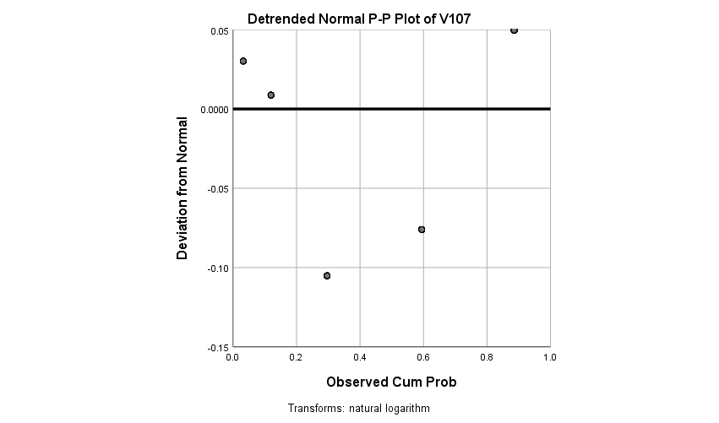

**V108**

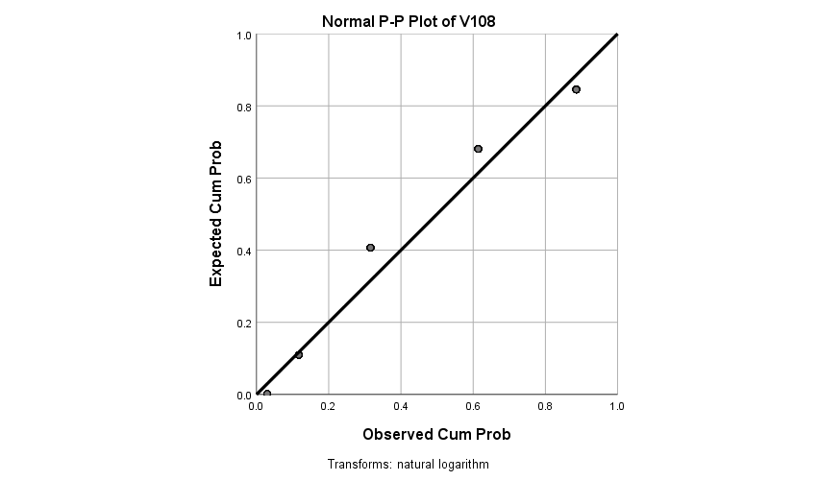

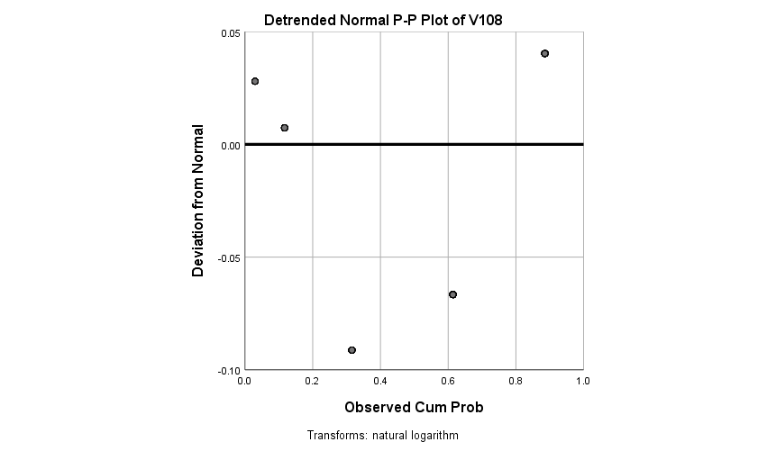

**V109**

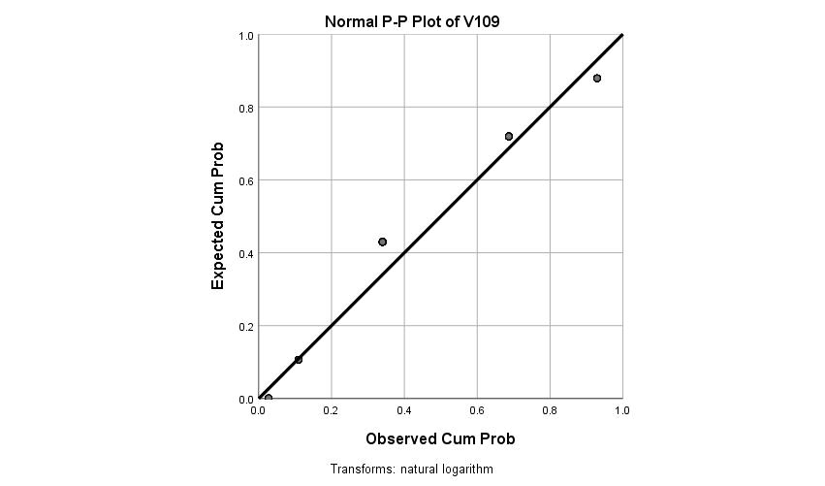

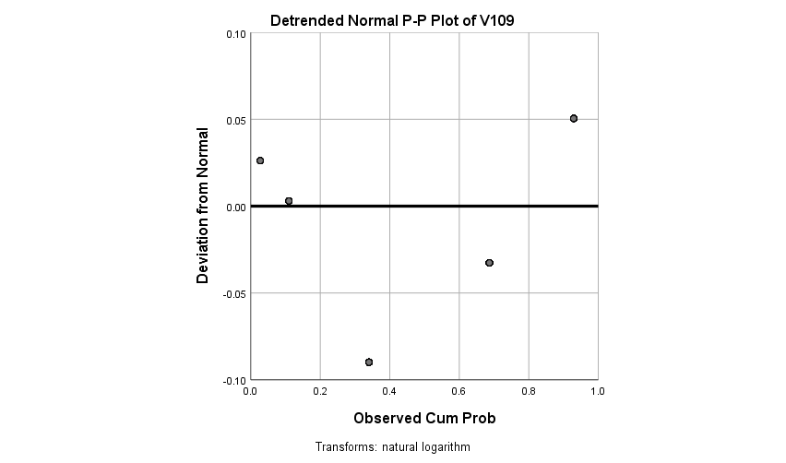

**V110**

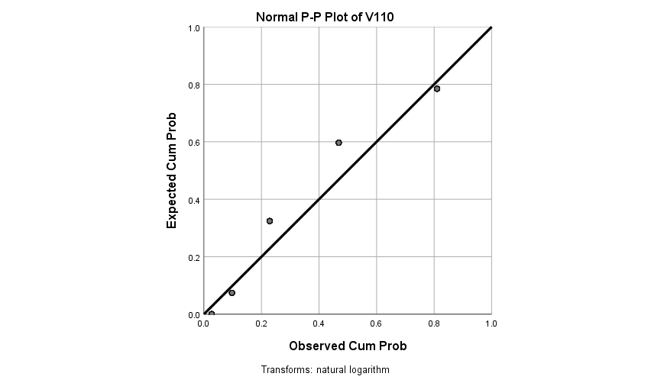

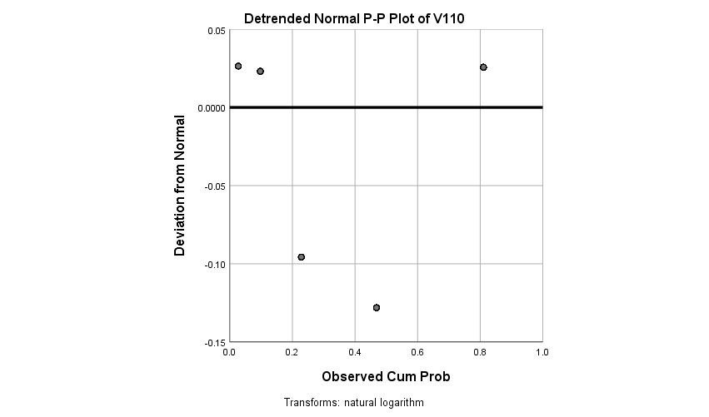

**V111**

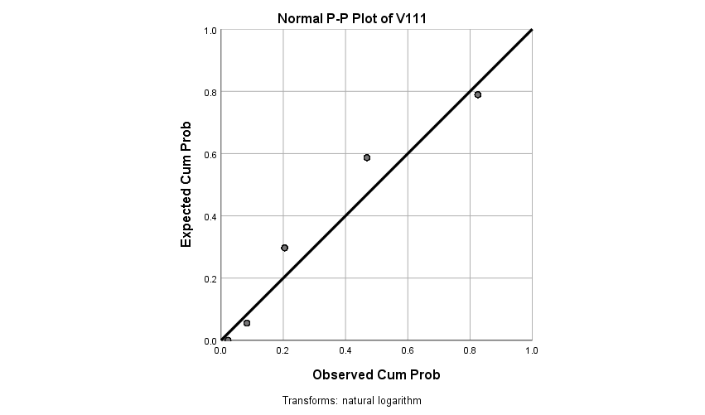

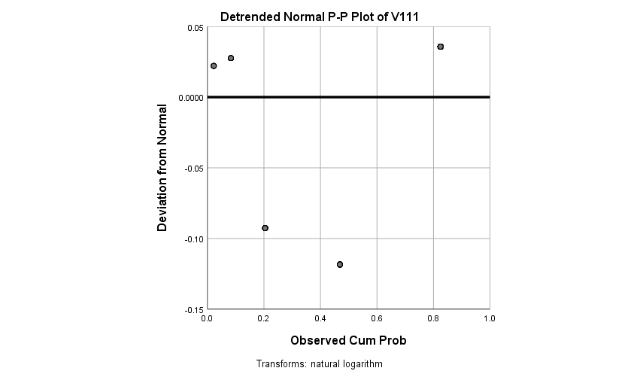

**V112**

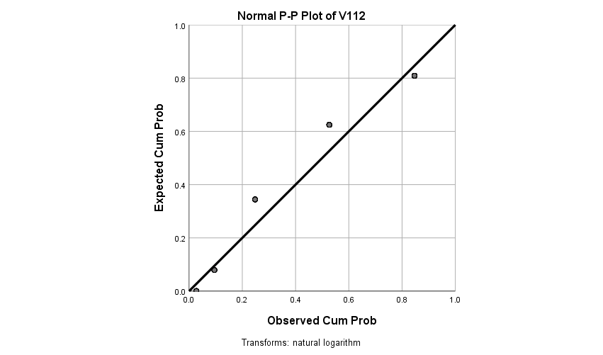

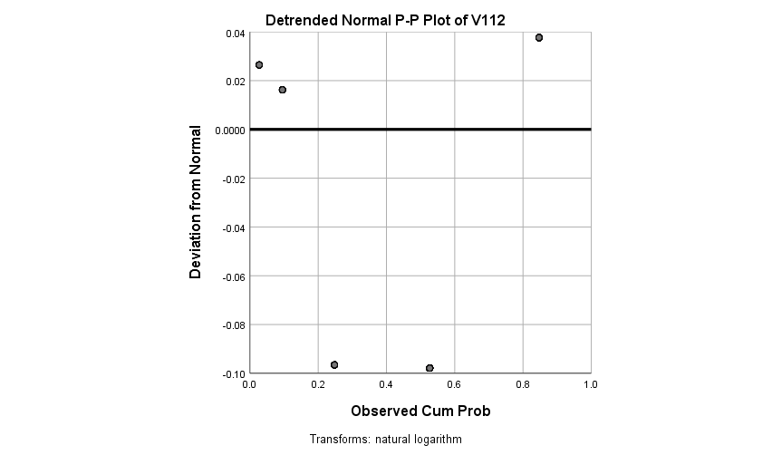

**How respondents see themselves? Such as extraverted enthusiastic, critical, self-disciplined, etc.**

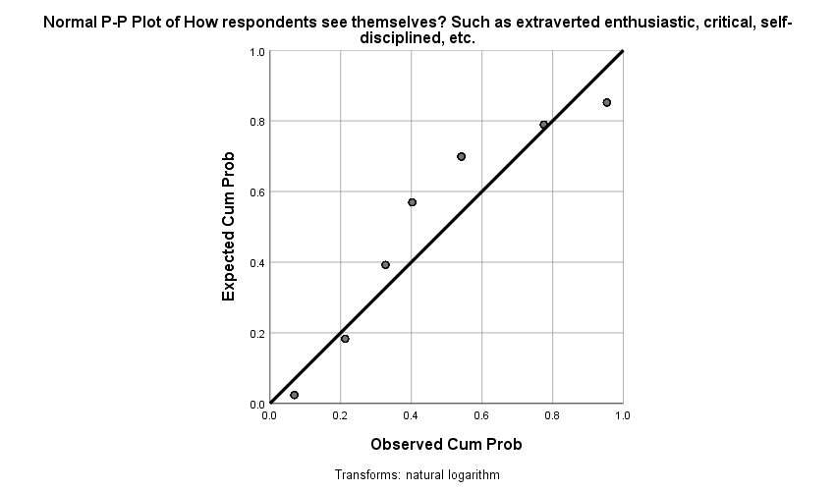

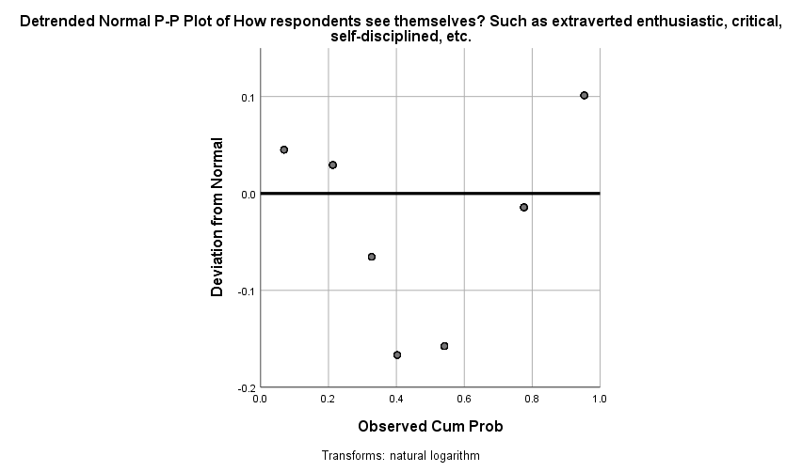

**V114**

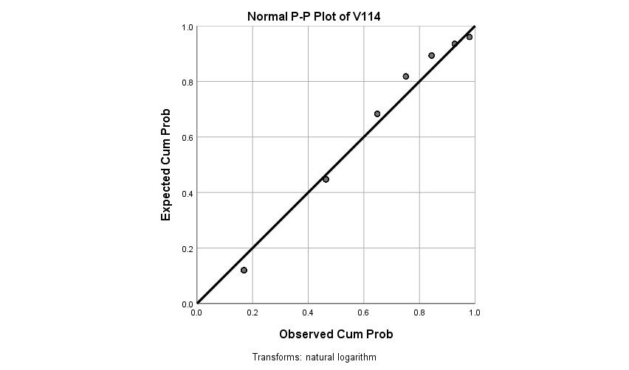

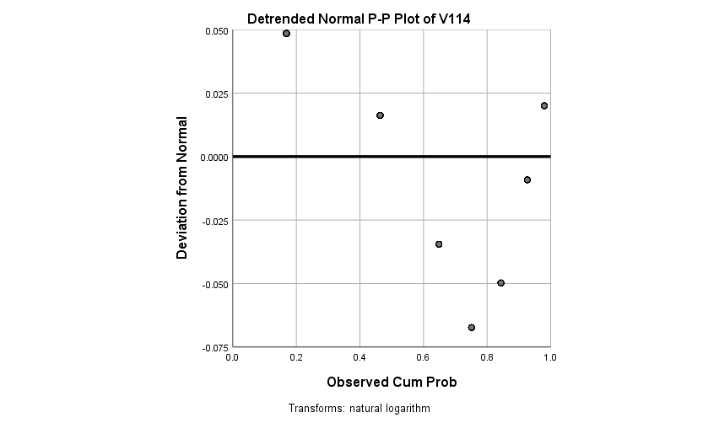

**V115**

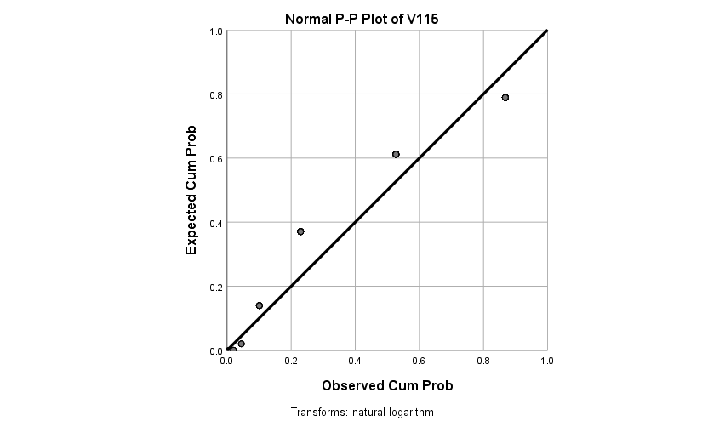

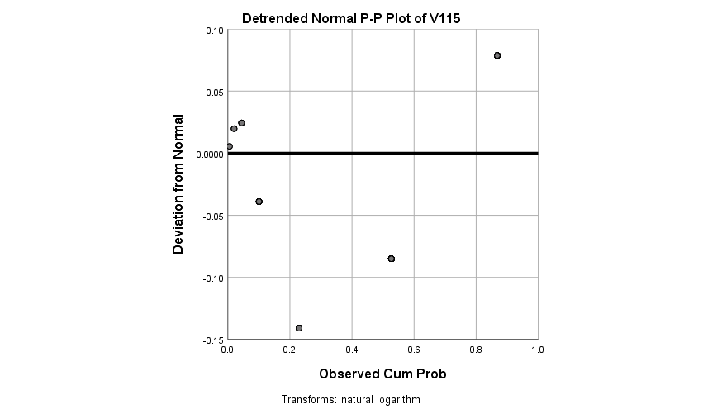

**V116**

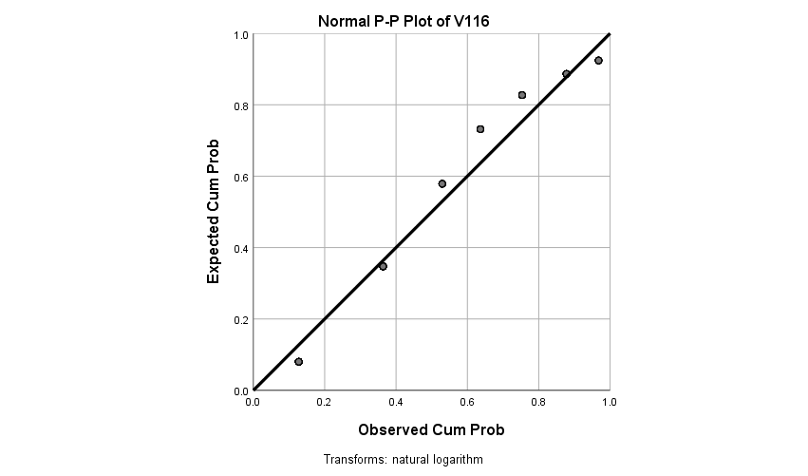

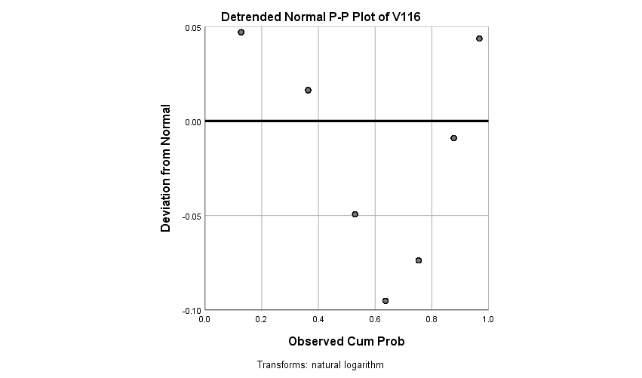

**V117**

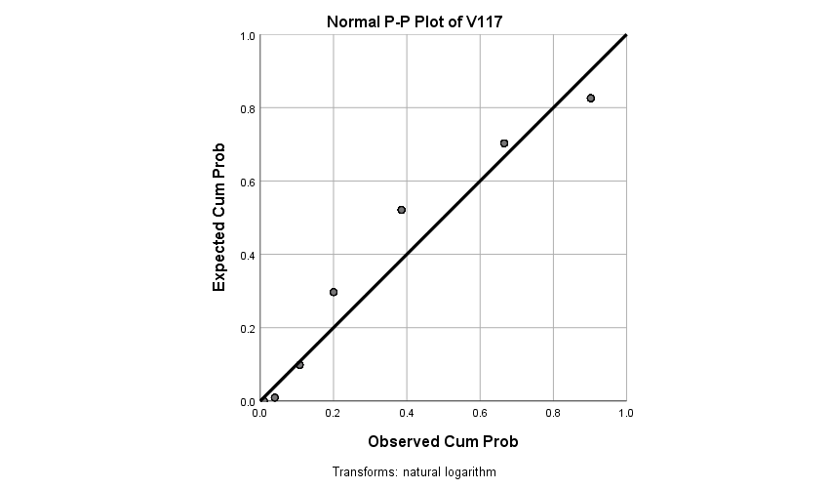

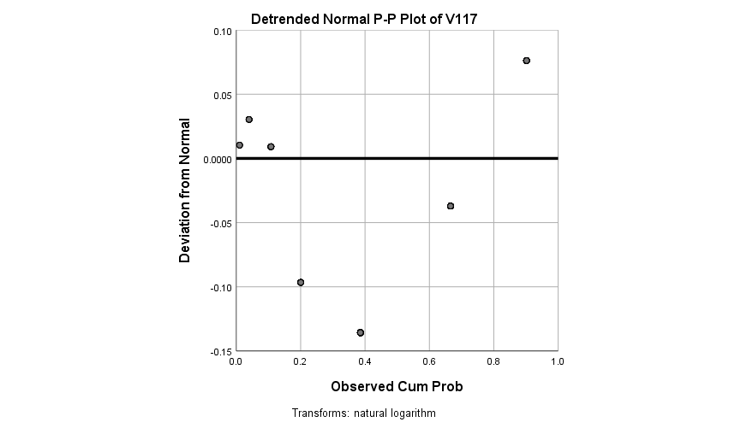

**V118**

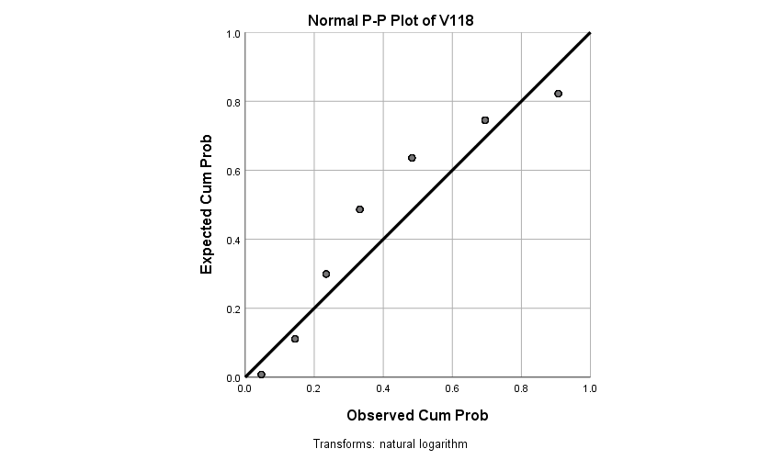

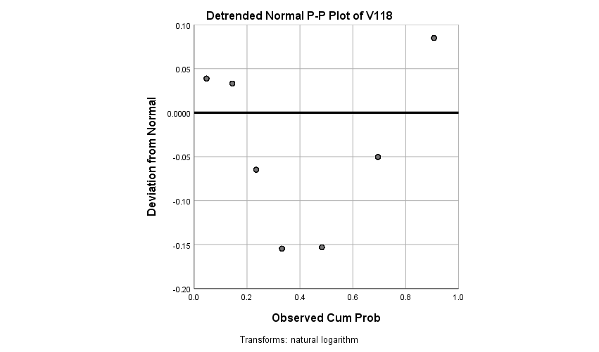

**V119**

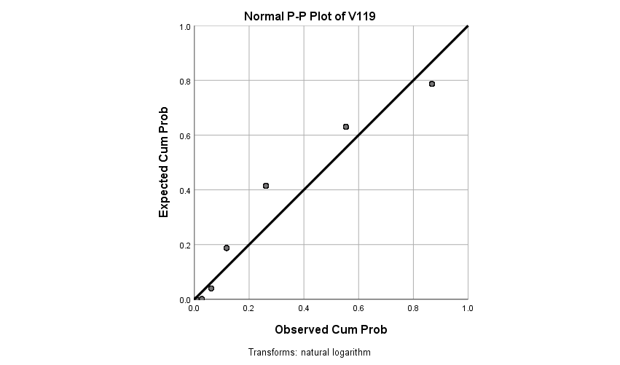

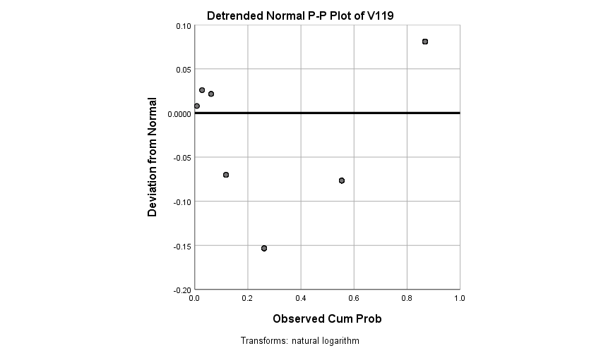

**V120**

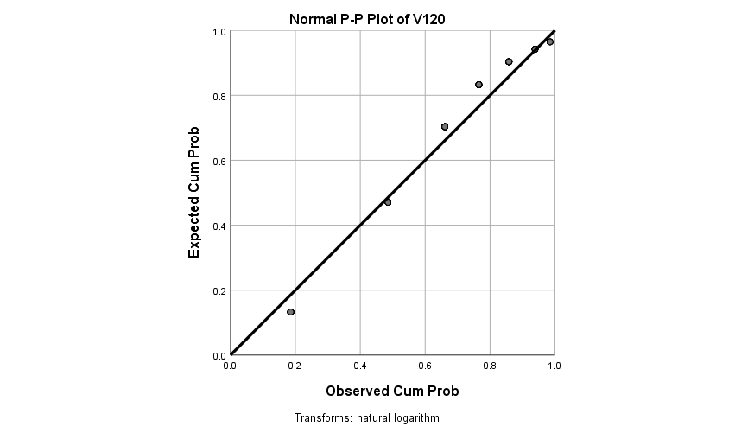

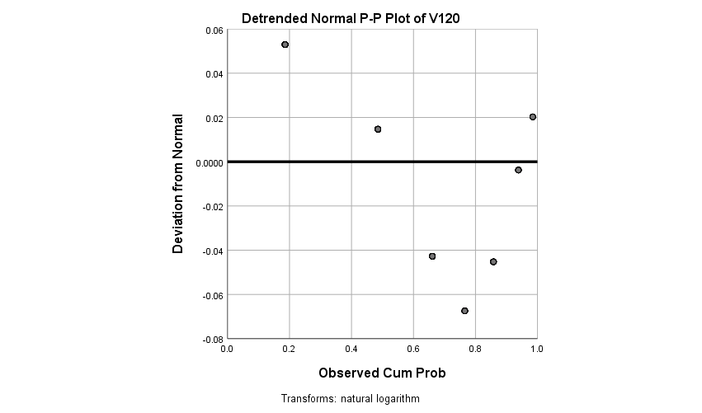

**V121**

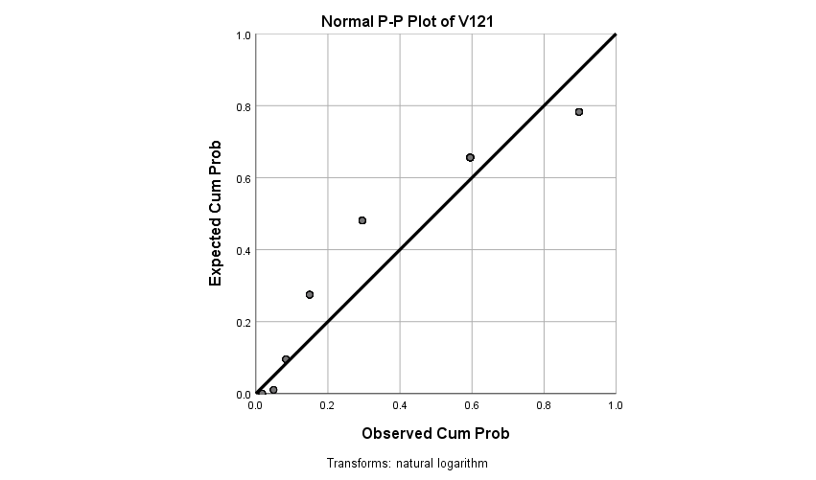

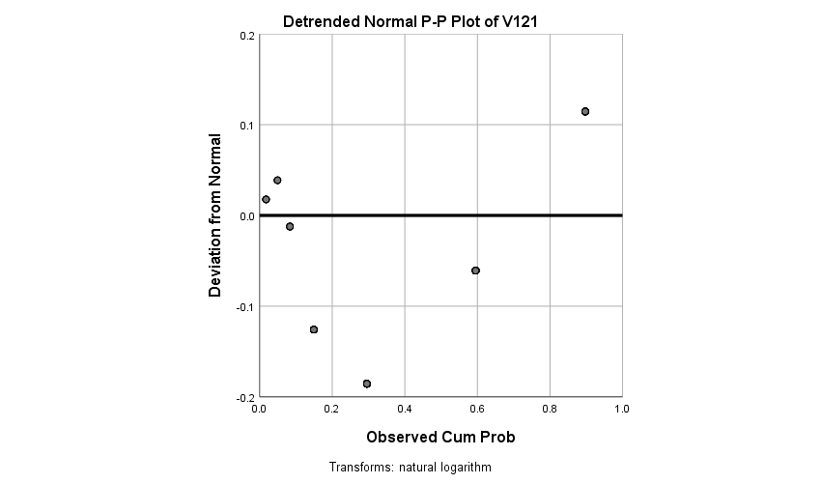

**V122**

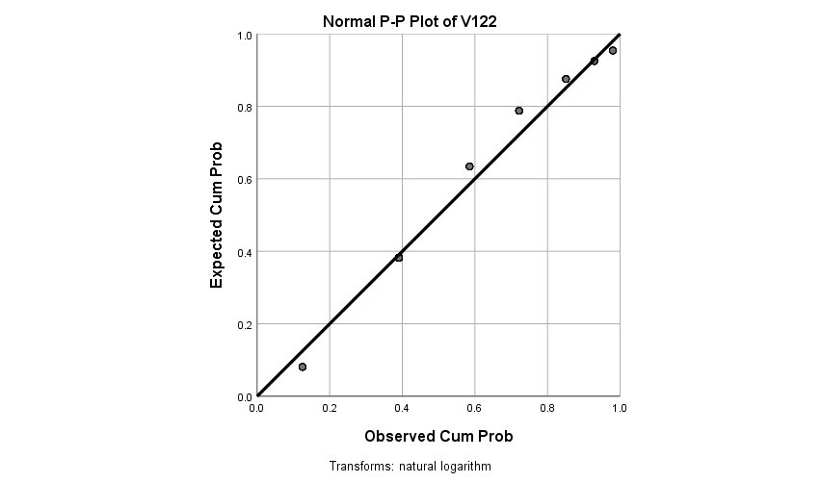

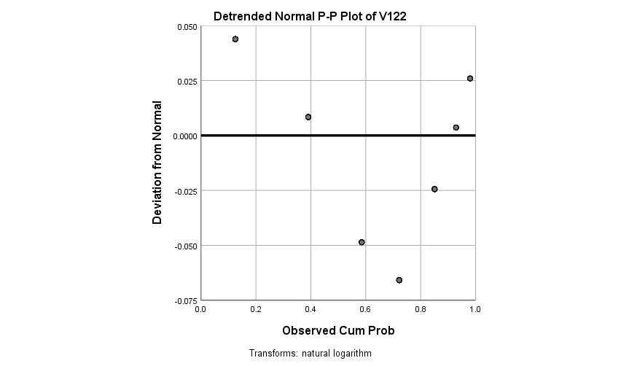

**Marker Items**

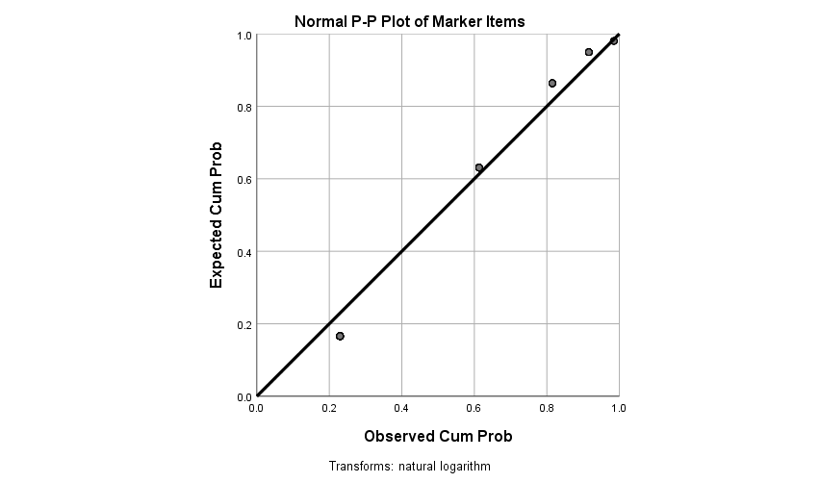

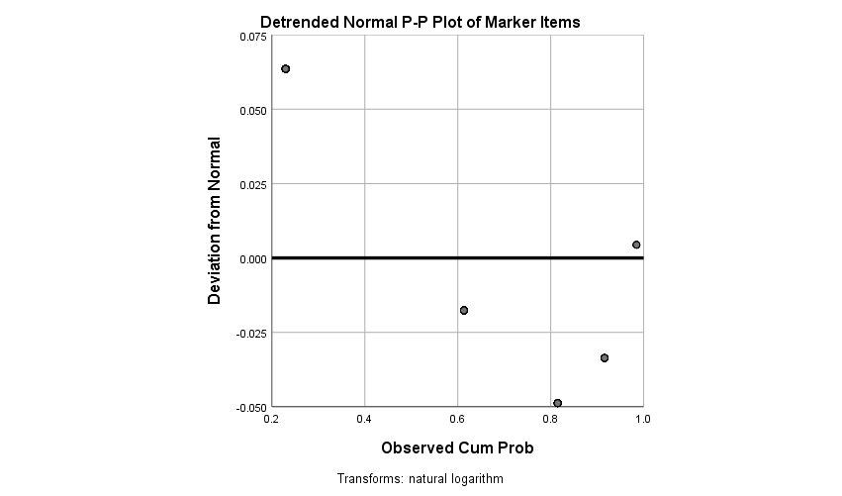

**V124**

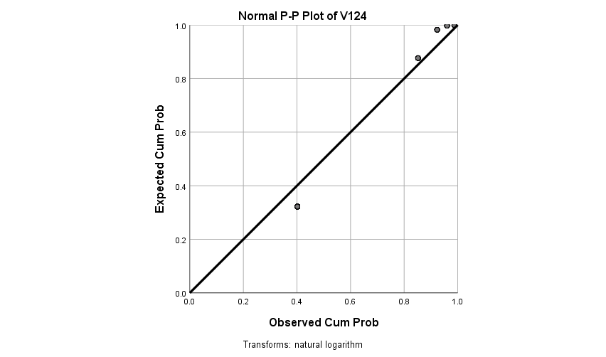

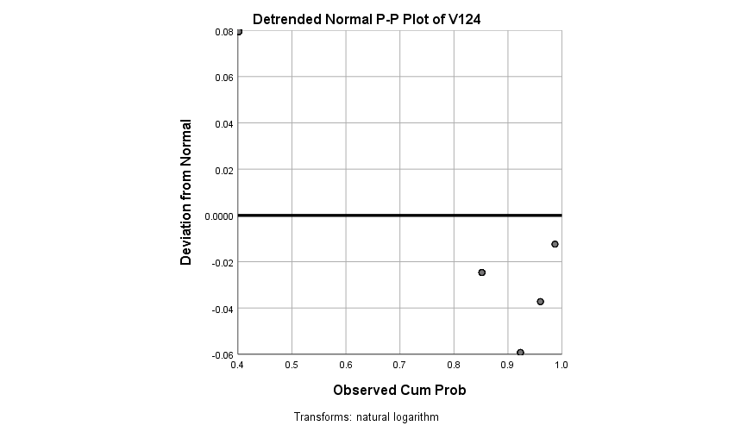

**V125**

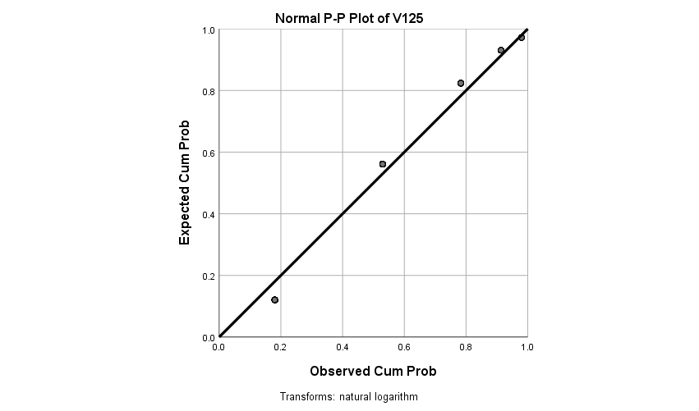

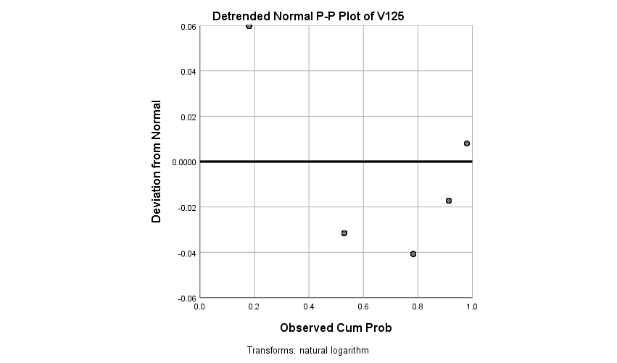

**V126**

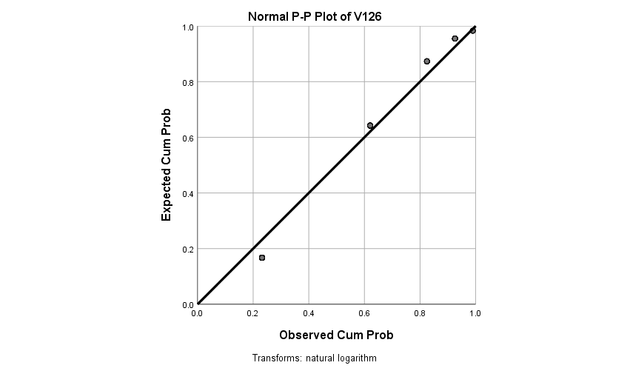

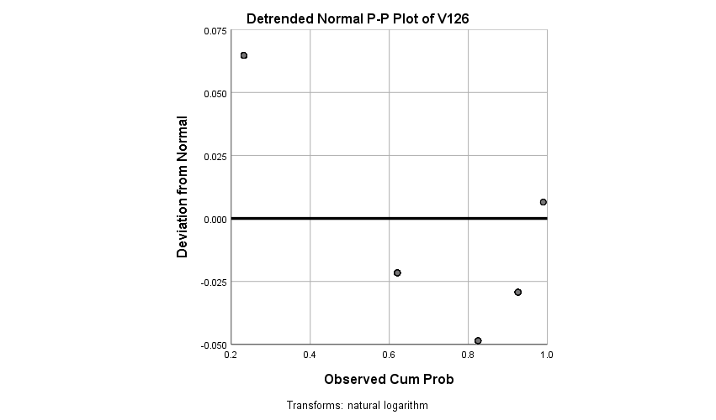

HYPOTHESIS TEST

**1.**

**Generalized Linear Models**

|  |  |
| --- | --- |
| **Model Information** | |
| Dependent Variable | V23 |
| Probability Distribution | Normal |
| Link Function | Identity |
| Scale Weight Variable | V24 |

|  |  |  |
| --- | --- | --- |
| **Case Processing Summary** | | |
|  | N | Percent |
| Included | 188 | 79.3% |
| Excluded | 49 | 20.7% |
| Total | 237 | 100.0% |

|  |  |  |  |  |  |  |
| --- | --- | --- | --- | --- | --- | --- |
| **Continuous Variable Information** | | | | | | |
|  | | N | Minimum | Maximum | Mean | Std. Deviation |
| Dependent Variable | V23 | 188 | 1 | 2 | 1.13 | .340 |
| Scale Weight | V24 | 188 | 1 | 11 | 4.93 | 2.912 |

|  |  |  |  |
| --- | --- | --- | --- |
| **Goodness of Fita** | | | |
|  | Value | df | Value/df |
| Deviance | 101.484 | 187 | .543 |
| Scaled Deviance | 188.000 | 187 |  |
| Pearson Chi-Square | 101.484 | 187 | .543 |
| Scaled Pearson Chi-Square | 188.000 | 187 |  |
| Log Likelihoodb | -78.625 |  |  |
| Akaike's Information Criterion (AIC) | 161.250 |  |  |
| Finite Sample Corrected AIC (AICC) | 161.315 |  |  |
| Bayesian Information Criterion (BIC) | 167.723 |  |  |
| Consistent AIC (CAIC) | 169.723 |  |  |
| Dependent Variable: V23  Model: (Intercept) | | | |
| a. Information criteria are in smaller-is-better form. | | | |
| b. The full log likelihood function is displayed and used in computing information criteria. | | | |

|  |  |  |
| --- | --- | --- |
| **Omnibus Testa** | | |
| Likelihood Ratio Chi-Square | df | Sig. |
| .000 | . | . |
| Dependent Variable: V23  Model: (Intercept) | | |
| a. Compares the fitted model against the intercept-only model. | | |

|  |  |  |  |
| --- | --- | --- | --- |
| **Tests of Model Effects** | | | |
| Source | Type III | | |
| Wald Chi-Square | df | Sig. |
| (Intercept) | 2173.940 | 1 | .000 |
| Dependent Variable: V23  Model: (Intercept) | | | |

|  |  |  |  |  |  |  |  |
| --- | --- | --- | --- | --- | --- | --- | --- |
| **Parameter Estimates** | | | | | | | |
| Parameter | B | Std. Error | 95% Wald Confidence Interval | | Hypothesis Test | | |
| Lower | Upper | Wald Chi-Square | df | Sig. |
| (Intercept) | 1.125 | .0241 | 1.078 | 1.172 | 2173.940 | 1 | .000 |
| (Scale) | .540a | .0557 | .441 | .661 |  |  |  |
| Dependent Variable: V23  Model: (Intercept) | | | | | | | |
| a. Maximum likelihood estimate. | | | | | | | |

|  |  |  |  |  |  |  |  |
| --- | --- | --- | --- | --- | --- | --- | --- |
| **Parameter Estimates** | | | | | | | |
| Parameter | B | Std. Error | 95% Wald Confidence Interval | | Hypothesis Test | | |
| Lower | Upper | Wald Chi-Square | df | Sig. |
| (Intercept) | 1.125 | .0241 | 1.078 | 1.172 | 2173.940 | 1 | .000 |
| (Scale) | .540a | .0557 | .441 | .661 |  |  |  |
| Dependent Variable: V23  Model: (Intercept) | | | | | | | |
| a. Maximum likelihood estimate. | | | | | | | |

2.A AND 2B

[DataSet2] E:\ONLINE WORKING\SPSS_Data_Analysis\Primacy Study One Summer 2021 CLASS Data.sav

|  |  |  |  |  |  |
| --- | --- | --- | --- | --- | --- |
| **Bayesian Estimates of Coefficientsa,b,c,d** | | | | | |
| Parameter | Posterior | | | 95% Credible Interval | |
| Mode | Mean | Variance | Lower Bound | Upper Bound |
| Condition (1 = P, 2 = N, 3 = M) = Positive-trait first (P) | 4.307 | 4.307 | .039 | 3.919 | 4.694 |
| Condition (1 = P, 2 = N, 3 = M) = Negative-trait first (N) | 3.889 | 3.889 | .049 | 3.452 | 4.325 |
| Condition (1 = P, 2 = N, 3 = M) = Mixed-trait (M) | 3.778 | 3.778 | .046 | 3.358 | 4.197 |
| a. Dependent Variable: Part II: I think Casey is imaginative | | | | | |
| b. Model: Condition (1 = P, 2 = N, 3 = M) | | | | | |
| c. Regression Weight Variable: Part II: I think Casey is pleasant | | | | | |
| d. Assume standard reference priors. | | | | | |

|  |  |  |  |  |  |
| --- | --- | --- | --- | --- | --- |
| **Bayesian Estimates of Error Variancea** | | | | | |
| Parameter | Posterior | | | 95% Credible Interval | |
| Mode | Mean | Variance | Lower Bound | Upper Bound |
| Error variance | 5.107 | 5.333 | .646 | 3.986 | 7.127 |
| a. Assume standard reference priors. | | | | | |

**Bayesian ANOVA**

[DataSet5] E:\ONLINE WORKING\SPSS_Data_Analysis\Primacy Study One Summer 2021 CLASS Data.sav

|  |  |  |  |  |  |
| --- | --- | --- | --- | --- | --- |
| **Bayesian Estimates of Coefficientsa,b,c,d** | | | | | |
| Parameter | Posterior | | | 95% Credible Interval | |
| Mode | Mean | Variance | Lower Bound | Upper Bound |
| Attention Check (1 = P, 2 = N, 3 = M) = Positive | 1.400 | 1.400 | .011 | 1.196 | 1.604 |
| Attention Check (1 = P, 2 = N, 3 = M) = Neutral | 2.900 | 2.900 | .012 | 2.683 | 3.117 |
| Attention Check (1 = P, 2 = N, 3 = M) = Negative | 1.895 | 1.895 | .009 | 1.713 | 2.076 |
| a. Dependent Variable: Condition (1 = P, 2 = N, 3 = M) | | | | | |
| b. Model: Attention Check (1 = P, 2 = N, 3 = M) | | | | | |
| c. Regression Weight Variable: Gender (1 = M, 2 = F) | | | | | |
| d. Assume standard reference priors. | | | | | |

|  |  |  |  |  |  |
| --- | --- | --- | --- | --- | --- |
| **Bayesian Estimates of Error Variancea** | | | | | |
| Parameter | Posterior | | | 95% Credible Interval | |
| Mode | Mean | Variance | Lower Bound | Upper Bound |
| Error variance | .466 | .486 | .005 | .363 | .650 |
| a. Assume standard reference priors. | | | | | |